 | 

Laboratory Manual
Course Name: Hydraulic Engineering
Course Code: CE432P
School of Engineering and Technology
HYDRAULIC ENGINEERING – Laboratory Manual
Academic Year: 2026–2027
Department: Department of Civil Engineering
Laboratory: Hydraulic Engineering Laboratory
Room: Block V

Instructors: Dr Arpan Pradhan, Dr Sirisha Uppaluri

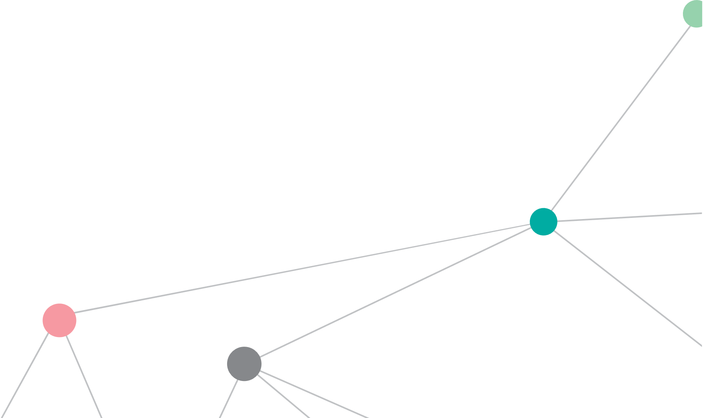

LABORATORY MANUAL
Hydraulic Engineering
CE432P
Student Name:
Registration Number:
Class / Section:
Semester:
Department:
Academic Year:

Certified that this is a bonafide record of the work done by the above student in the Hydraulic Engineering Laboratory during the academic year ________________.

Signature of Faculty

VISION and MISSION

VISION
Serve and excel in the constantly changing societal needs with ethics and integrity.

MISSION
- M1. To create awareness of societal needs and ethics in the dynamic environment.
- M2. To impart contemporary knowledge to achieve excellence in academics and profession through the experience of lifelong learning.
- M3. To carry out research in collaboration with research organizations and industry to add value to the profession and society at large.
- M4. To instil leadership qualities, communication skills and team spirit to meet challenges in the global environment.

PEOs and PSOs

PROGRAMME EDUCATIONAL OBJECTIVES (PEOs)
Graduates of the programme will possess the following:
- PEO1. Fundamental Knowledge: A competent professional, aware of societal needs, who applies fundamental knowledge and technical skills to analyse and support the activities in the field.
- PEO2. Lifelong Learning: Facilitate programmes of lifelong learning, through skill-based courses and interaction with industry, leading to professional expertise.
- PEO3. Research and Consultancy: Engage in research and consultancy projects of the department.
- PEO4. Leadership Qualities: Develop a sense of social responsibility, leadership qualities, communication skills and team spirit.

PROGRAMME SPECIFIC OBJECTIVES (PSOs)
Graduates of the programme will be able to:
- PSO1. Analyse and design structural systems: Analyse, design, construct and manage sustainable structural systems.
- PSO2. Investigate civil engineering materials: Investigate the properties of civil engineering materials.
- PSO3. Modern surveying: Plan buildings, maps, and alignments for canals and roads using modern surveying instruments.

Engineering Graduate Attributes
- Engineering knowledge: Apply the knowledge of mathematics, science, engineering fundamentals, and an engineering specialization to the solution of complex engineering problems.
- Problem analysis: Identify, formulate, review research literature, and analyse complex engineering problems reaching substantiated conclusions using first principles of mathematics, natural sciences, and engineering sciences.
- Design/development of solutions: Design solutions for complex engineering problems and design system components or processes that meet the specified needs with appropriate consideration for public health and safety, and cultural, societal, and environmental considerations.
- Conduct investigations of complex problems: Use research-based knowledge and research methods including design of experiments, analysis and interpretation of data, and synthesis of the information to provide valid conclusions.
- Modern tool usage: Create, select, and apply appropriate techniques, resources, and modern engineering and IT tools including prediction and modelling to complex engineering activities with an understanding of the limitations.
- The engineer and society: Apply reasoning informed by contextual knowledge to assess societal, health, safety, legal and cultural issues and the consequent responsibilities relevant to professional engineering practice.
- Environment and sustainability: Understand the impact of professional engineering solutions in societal and environmental contexts, and demonstrate the knowledge of, and need for, sustainable development.
- Ethics: Apply ethical principles and commit to professional ethics and responsibilities and norms of engineering practice.
- Individual and team work: Function effectively as an individual, and as a member or leader in diverse teams, and in multidisciplinary settings.
- Communication: Communicate effectively on complex engineering activities with the engineering community and with society at large, such as being able to comprehend and write effective reports and design documentation, make effective presentations, and give and receive clear instructions.
- Project management and finance: Demonstrate knowledge and understanding of engineering and management principles and apply these to one’s own work, as a member and leader in a team, to manage projects and in multidisciplinary environments.
- Life-long learning: Recognize the need for, and have the preparation and ability to engage in, independent and life-long learning in the broadest context of technological change.

Course Details
Course Name: Hydraulic Engineering |  |  |  | Course Code: CE432P
 | L | T | P | Category | PCC
Contact hours / week | 3 | 0 | 2 | CIA marks | 70
Contact hours / semester | 45 | 0 | 30 | ESE marks | 30
Credits | 3 | 0 | 1 | Exam hours | 3

Course Objective
To introduce students to hydraulic engineering problems such as open channel flow and hydraulic machines. On completion of the course, the student should be able to relate the theory and practice of problems in hydraulic engineering.

Prerequisite
Introduction to Fluid Mechanics.

Course Outcomes
Upon completion of this course the student will be able to:
- CO1: Differentiate laminar and turbulent flow (L2, L3) (PO1, PO2) (PSO3).
- CO2: Explain the concept of boundary layer theory (L2, L3) (PO1, PO2) (PSO3).
- CO3: Determine the most economical channel section and analyse the hydraulic jump (L3, L4) (PO1, PO2) (PSO3).
- CO4: Analyse the characteristics of hydraulic machines for efficiency (L4) (PO1, PO2) (PSO3).
- CO5: Explain the importance of computational fluid dynamics in modelling of water resources (L2) (PO1, PO2) (PSO3).
- CO6: Calibrate flow-measuring devices and hydraulic machines (L5) (PO1, PO2, PO9, PO10) (PSO3) – the laboratory outcome addressed by this manual.

Textbooks
- R. K. Bansal, Fluid Mechanics and Hydraulic Machines, revised 9th ed., Laxmi Publications, New Delhi, 2018.
- A. K. Jain, Fluid Mechanics, Khanna Publishers, New Delhi, 2016.
- P. N. Modi and S. M. Seth, Hydraulics and Fluid Mechanics including Hydraulic Machines, 21st ed., Standard Book House, New Delhi, 2017.
- K. Subramanya, Theory and Applications of Fluid Mechanics, Tata McGraw-Hill, 2014.

Reference Books
- Ven Te Chow, Open-Channel Hydraulics, McGraw-Hill.
- S. S. Rattan, Fluid Mechanics and Hydraulic Machines, Khanna Publishing House, 2014.
- C. S. P. Ojha, R. Berndtsson and P. N. Chandramouli, Fluid Mechanics and Machinery, Oxford University Press, 2016.

Table of Contents
Sl. No. | Date | Experiment | Page No. | Marks | Faculty Signature
1 |  | Calibration of V-notch | 11–17
2 |  | Calibration of Rectangular Notch | 19–24
3 |  | Calibration of Ogee Weir | 25–30
4 |  | Calibration of Broad-Crested Weir | 31–36
5 |  | Calibration of Venturi-meter | 37–42
6 |  | Calibration of Orifice-meter | 43–48
7 |  | Determination of the Hydraulic Coefficients of a Vertical Orifice | 49–56
8 |  | Determination of Darcy’s Friction Factor for a Straight Pipe | 57–64
9 |  | Determination of Minor Loss Constants (Sudden Expansion, Sudden Contraction and Bend) | 65–72
10 |  | Determination of Vane Coefficient for Flat and Hemispherical Vanes | 73–80
11 |  | Performance Tests on a Single-Stage Centrifugal Pump | 81–88
12 |  | Performance Tests on a Pelton Wheel Turbine | 89–96
13 |  | Performance Tests on a Francis Turbine | 97–104
14 |  | Performance Tests on a Kaplan Turbine | 105–113
 |  | Total Marks

Date: | V-Notch

1 Calibration of V-notch

1.1 Aim of the Experiment
To determine the coefficient of discharge (C_{d}) of a given V-notch (triangular notch).

1.2 Objective
To experimentally determine the coefficient of discharge (C_{d}) of a V-notch by measuring the head over the notch and the corresponding flow rate, and to establish the head–discharge (calibration) relationship of the notch.

1.3 Theory
A notch is an opening provided in the side of a tank or channel such that the liquid surface upstream is below the top edge of the opening. It is used to measure the flow rate through a small channel or tank. A weir serves the same purpose but is larger and is usually a concrete or masonry structure, whereas a notch is generally made of a metal plate. The sheet of water flowing over a notch is called the nappe (or vein), and the bottom edge of the notch over which water flows is the sill or crest; its height above the channel bed is the crest height.
A V-notch (triangular notch) has a V-shaped opening. It is preferred to a rectangular notch for measuring low discharges, because the width of flow increases with head, so a small discharge still produces a measurable head and the accuracy is higher.
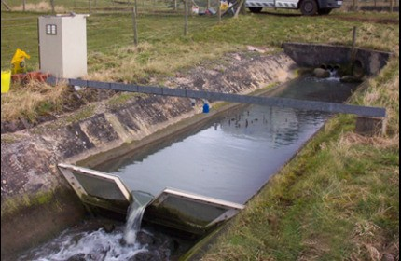
Figure 1: V-notch in an irrigation canal

Derivation of the discharge equation
Consider a V-notch of apex angle $θ$ with head $H$ above the vertex (Figure 2). Take an elementary horizontal strip of thickness $dy$ at depth $y$ below the free surface.
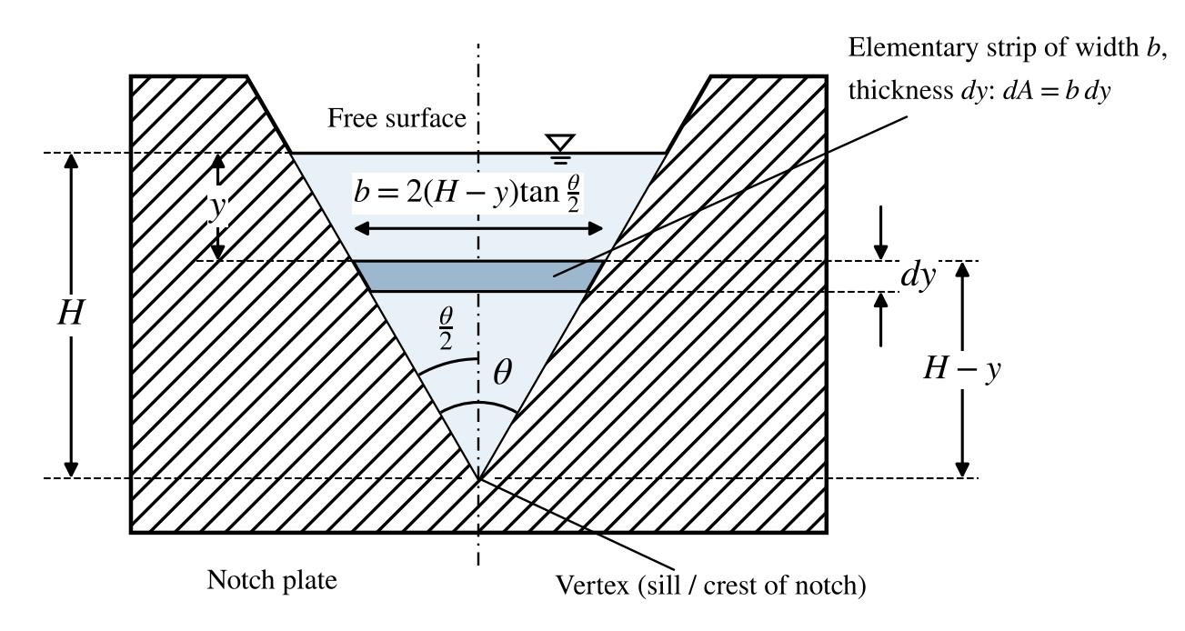
Figure 2: Elementary strip in a V-notch – notation used in the derivation
Width of the strip: $b=2(H-y)tan\left(\frac{θ}{2}\right)$; velocity through the strip (Torricelli): $v=\sqrt{2gy}$
Discharge through the strip:
$$dQ=C_{d}· 2(H-y)tan\left(\frac{θ}{2}\right)\sqrt{2gy} dy$$
Integrating from $y=0$ to $y=H$:
$$Q=2C_{d}tan\left(\frac{θ}{2}\right)\sqrt{2g}\int_{0}^{H}{(H-y)y^{1/2}dy=2C_{d}tan\left(\frac{θ}{2}\right)\sqrt{2g}\left(\frac{2}{3}H^{5/2}-\frac{2}{5}H^{5/2}\right)}$$
$$Q_{act}=\frac{8}{15}C_{d}\sqrt{2g}tan\left(\frac{θ}{2}\right)H^{5/2}$$
The theoretical discharge (ideal fluid, $C_{d}=1$) is therefore
$$Q_{th}=\frac{8}{15}\sqrt{2g}tan\left(\frac{θ}{2}\right)H^{5/2}$$
and the coefficient of discharge, which accounts for contraction of the nappe and energy losses, is
$$C_{d}=\frac{Q_{act}}{Q_{th}}$$
where $Q$ = discharge (m³/s), $C_{d}$ = coefficient of discharge (dimensionless), $θ$ = apex angle of the notch, $H$ = head of water above the vertex (m), and $g$ = 9.81 m/s².

1.4 Apparatus
- A channel fitted with vertical perforated (baffle) plates to reduce the velocity of approach, with arrangement for regulated supply of water
- V-notch (triangular notch) plate
- Pointer gauge (hook gauge with vernier scale) for measuring the head of water over the crest
- Collecting (measuring) tank fitted with a piezometer tube and graduated scale
- Stopwatch

1.5 Experimental Setup
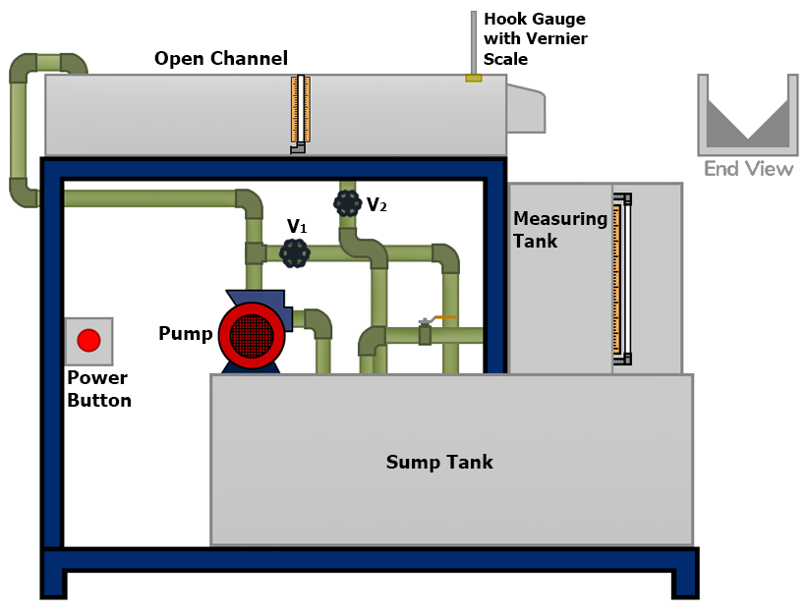
Figure 3: Experimental setup for notch and weir calibration

1.6 Data
- Area of measuring tank, $A$ = 0.2 m²
- Apex angle of the V-notch, $θ$ = 60°

1.7 Experimental Procedure
- Note down the apex angle of the V-notch and the dimensions of the collecting tank.
- Open the bypass valve (V₁), close all other valves, start the pump and allow water to rise just up to the sill (vertex) of the notch.
- Adjust the pointer gauge so that its tip just touches the water surface and note the initial reading h₁.
- Open the inlet valve (V₂) so that water flows over the notch. Wait until the flow becomes steady.
- Bring the pointer gauge tip to the new water surface and note the final reading h₂. The difference h₂ − h₁ gives the head H over the notch.
- Close the drain valve of the measuring tank and note the time t for a known rise R (say 100 mm) of water level in the tank.
- Repeat steps 4–6 for at least four different discharges (¼, ½, ¾ and full valve opening).
- Stop the pump and open the drain valve to empty the measuring tank.

1.8 Observations
Table 1: Readings – V-notch
Sl. No. | Valve opening | Head of water over crest |  |  |  | Collection of water discharged
Sl. No. | Valve opening | Initial h₁ (mm) | Final h₂ (mm) | h = h₂ − h₁ (mm) | H (m) | Rise R (mm) | Time t (s)
1 | ¼ opening
2 | ½ opening
3 | ¾ opening
4 | Full opening

1.9 Specimen Calculations
1. Actual discharge
$$Q_{act}=\frac{A× R}{t}= .............................. m^{3}/s$$
where $A$ = area of measuring tank (m²), $R$ = rise of water level in the tank (m), $t$ = time for rise $R$ (s).
2. Theoretical discharge
$$Q_{th}=\frac{8}{15}\sqrt{2g}tan\left(\frac{θ}{2}\right)H^{5/2}= .............................. m^{3}/s$$
3. Coefficient of discharge
$$C_{d}=\frac{Q_{act}}{Q_{th}}= ....................$$
Table 2: Calculations – V-notch
Sl. No. | Valve opening | Actual discharge Q_{act} (m³/s) | Theoretical discharge Q_{th} (m³/s) | Coefficient of discharge C_{d}
1 | ¼ opening
2 | ½ opening
3 | ¾ opening
4 | Full opening
$$C_{d,avg}=\frac{Σ C_{d}}{4}= ....................$$

1.10 Graphs
- Plot $Q_{act}$ versus $H$ (calibration curve).
- Plot $log Q_{act}$ versus $log H$ and fit $Q_{act}=KH^{n}$; the slope gives $n$ (theoretically 2.5) and the intercept gives $K$.

1.11 Precautions
- Ensure steady flow conditions before recording any reading.
- Measure the head accurately with the pointer gauge; avoid parallax error.
- Avoid turbulence and surface waves near the notch to ensure smooth flow.
- The nappe should spring clear of the notch (free, aerated flow).

1.12 Sources of Error
- Errors in head measurement due to meniscus or parallax.
- Inaccurate time measurement with the stopwatch.
- Fluctuations in water head due to supply variations.

1.13 Applications
V-notches are commonly used in open-channel flow measurement – irrigation channels, drainage and wastewater treatment facilities – particularly where flows are small.

1.14 Result
The coefficient of discharge of the V-notch has been determined at different discharges.
The average coefficient of discharge of the V-notch, C_{d} = ________________

1.15 Conclusion
Discuss the variation of C_{d} with head, the value of the exponent n obtained from the log–log plot, and the reasons for any difference between theoretical and actual discharge.

Signature of Faculty

Rough Work

Viva Voce Questions
- What is coefficient of discharge, and what it indicates about fluid flow through a notch?
- What is the purpose of using a V-notch for discharge, compared to other notches?
- Explain the relationship between discharge and head in the context of a V-notch.
- How is the theoretical discharge calculated over a V-notch?
- How does the angle of the V-notch affect the discharge measurement?
- What is the mathematical formula for discharge over a V-notch?
- Define “head” in this experiment and explain its role in calculating discharge.
- How do you measure the head in this experiment accurately?
- What factors can affect the accuracy of the coefficient of discharge in this experiment?
- Describe the purpose of calibrating the apparatus before taking measurements.
- What is meant by “free flow” over a notch, and why is it essential for this experiment?
- What precautions should be taken to avoid turbulence in the flow during the experiment?
- How would you reduce errors in measuring the head of water above the notch?
- What are some practical applications of V-notches?
- How can sediment or debris affect discharge measurement accuracy?
- What is the importance of knowing the coefficient of discharge in real-life applications?
- Describe any alternative methods for measuring discharge other than using a V-notch.
- What are the limitations of using a V-notch for measuring discharge in certain conditions?
- How would you experimentally verify the theoretical formula for discharge over a V-notch?
- Compare the efficiency of discharge measurement in V-notch versus rectangular notch?

Date: | Rectangular Notch

2 Calibration of Rectangular Notch

2.1 Aim of the Experiment
To determine the coefficient of discharge (C_{d}) of a given rectangular notch.

2.2 Objective
To experimentally determine the coefficient of discharge of a rectangular notch by measuring the head over the crest and the corresponding flow rate, and to obtain its calibration curve.

2.3 Theory
A rectangular notch has a rectangular opening and is used for measuring relatively large discharges in open channels. The discharge depends on the height of water above the crest (the head $H$) and the width $b$ of the notch. The shape of the nappe changes with the head over the notch.

Derivation of the discharge equation
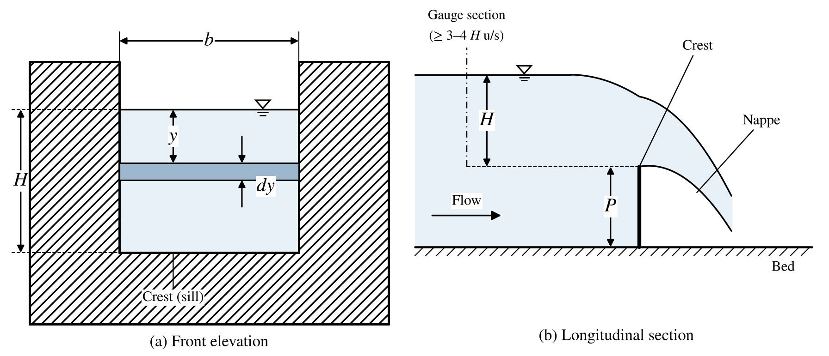
Figure 4: Rectangular notch – notation used in the derivation (b = width of notch, H = head over the crest, P = crest height)
Consider an elementary horizontal strip of thickness $dy$ at depth $y$ below the free surface. Its width is $b$ and the velocity through it is $\sqrt{2gy}$, so
$$dQ=C_{d} b\sqrt{2gy} dy$$
$$Q_{act}=C_{d} b\sqrt{2g}\int_{0}^{H}{y^{1/2}dy=\frac{2}{3}C_{d} b\sqrt{2g} H^{3/2}}$$
The theoretical discharge and the coefficient of discharge are
$$Q_{th}=\frac{2}{3}b\sqrt{2g} H^{3/2}$$
$$C_{d}=\frac{Q_{act}}{Q_{th}}$$
where $b$ = width of the notch normal to the flow (m) and $H$ = head over the crest (m).

2.4 Apparatus
- A channel fitted with vertical perforated plates to reduce the velocity of approach, with arrangement for regulated supply of water
- Rectangular notch plate
- Pointer gauge for measuring the head of water over the crest
- Collecting tank fitted with a piezometer tube and graduated scale
- Stopwatch

2.5 Data
- Area of measuring tank, $A$ = 0.2 m²
- Width of the notch normal to the flow, $b$ = ________________ m

2.6 Experimental Procedure
- Note down the width of the rectangular notch and the dimensions of the collecting tank.
- Open the valve and allow the water level to rise only up to the sill (crest) of the notch.
- Adjust the pointer gauge so that it coincides with the water surface and note the initial reading h₁.
- Open the inlet valve so that water flows over the notch; wait for steady flow to be established.
- Note the new water level h₂ by means of the pointer gauge. The difference h₂ − h₁ gives the head H over the notch.
- Note the time t for a known rise R of water level in the measuring tank.
- Repeat the procedure for at least four different discharges.

2.7 Observations
Table 3: Readings – rectangular notch
Sl. No. | Valve opening | Head of water over crest |  |  |  | Collection of water discharged
Sl. No. | Valve opening | Initial h₁ (mm) | Final h₂ (mm) | h = h₂ − h₁ (mm) | H (m) | Rise R (mm) | Time t (s)
1 | ¼ opening
2 | ½ opening
3 | ¾ opening
4 | Full opening

2.8 Specimen Calculations
1. Actual discharge
$$Q_{act}=\frac{A× R}{t}= .............................. m^{3}/s$$
2. Theoretical discharge
$$Q_{th}=\frac{2}{3}b\sqrt{2g} H^{3/2}= .............................. m^{3}/s$$
3. Coefficient of discharge
$$C_{d}=\frac{Q_{act}}{Q_{th}}= ....................$$
Table 4: Calculations – rectangular notch
Sl. No. | Valve opening | Actual discharge Q_{act} (m³/s) | Theoretical discharge Q_{th} (m³/s) | Coefficient of discharge C_{d}
1 | ¼ opening
2 | ½ opening
3 | ¾ opening
4 | Full opening
$$C_{d,avg}=\frac{Σ C_{d}}{4}= ....................$$

2.9 Graphs
- Plot $Q_{act}$ versus $H$.
- Plot $log Q_{act}$ versus $log H$ and obtain $n$ (theoretically 1.5) and $K$ in $Q_{act}=KH^{n}$.

2.10 Precautions
- Ensure steady flow conditions before taking measurements.
- Measure the head H accurately from the crest of the notch.
- Minimise turbulence at the notch to achieve a smooth flow.

2.11 Sources of Error
- Errors in head measurement due to meniscus or parallax.
- Inaccurate time measurement with the stopwatch.
- Unsteady flow due to variations in the water supply.

2.12 Applications
Rectangular notches are widely used in open-channel flow measurement, such as river-flow gauging, drainage, and water-treatment facilities.

2.13 Result
The coefficient of discharge of the rectangular notch has been determined at different discharges.
The average coefficient of discharge of the rectangular notch, C_{d} = ________________

2.14 Conclusion
Discuss any discrepancies between the theoretical and actual discharge values, along with possible reasons affecting C_{d}.

Signature of Faculty

Rough Work

Viva Voce Questions
- What is a rectangular notch, and where is it used for flow measurement?
- How does the flow over a rectangular notch differ from that over other types of notches, such as triangular or trapezoidal?
- What principle does the rectangular notch operate on for flow measurement?
- How is the flow rate determined using a rectangular notch?
- What is the equation used to calculate discharge over a rectangular notch?
- Why is calibration of a rectangular notch necessary?
- What is the relationship between the head (h) and discharge (Q) in a rectangular notch?
- What equipment is used to measure the head and flow rate in this experiment?
- How is the head over the rectangular notch measured during the experiment?
- How do you calculate the discharge coefficient (Cd) for a rectangular notch?
- What factors influence the discharge coefficient (Cd) for a rectangular notch?
- How does the width of the notch affect the flow rate?
- How is the flow coefficient (Cd) determined experimentally?
- How do you determine the flow rate for a given head in a rectangular notch?
- What role does the approach velocity play in the measurement of flow through a rectangular notch?
- How does the length of the notch affect the flow rate?
- What is the effect of submergence on the discharge measurement through a rectangular notch?
- How would you correct for the effect of submergence in a rectangular notch calibration?
- Why might the actual discharge differ from the theoretical discharge in a rectangular notch experiment?
- What are the primary sources of error in the calibration of a rectangular notch?
- How does the shape of the notch (e.g., sharp-edged or rounded) affect the flow measurement?
- How do you account for the effect of surface tension in the flow over a rectangular notch?
- How is the coefficient of discharge (Cd) for a rectangular notch influenced by the flow conditions?
- What assumptions are made when using the theoretical equation for flow over a rectangular notch?
- How does water temperature affect the performance of a rectangular notch in flow measurement?
- How does the approach channel geometry affect the discharge measurement in a rectangular notch?
- What is the importance of ensuring a smooth and clean notch edge for accurate flow measurement?
- How do you calculate the error margin in the discharge measurement for a rectangular notch?
- How can you use the calibration data to predict flow rates in real-world applications?
- How does the experimental setup affect the accuracy of the calibration for a rectangular notch?

Date: | Ogee Weir

3 Calibration of Ogee Weir

3.1 Aim of the Experiment
To determine the coefficient of discharge (C_{d}) of a given ogee weir.

3.2 Objective
To experimentally determine the coefficient of discharge of an ogee weir by measuring the head over the crest and the corresponding flow rate, and to obtain its calibration curve.

3.3 Theory
An ogee weir (ogee spillway) is an overflow weir whose crest and downstream face follow the shape of the lower surface of the nappe of a sharply ventilated sharp-crested weir. Because the water surface clings to the profile, sub-atmospheric pressures and separation are avoided at the design head, giving a high discharge capacity with little energy loss. Ogee profiles are used for the overflow sections of dams and in channels and rivers for flow control and measurement.
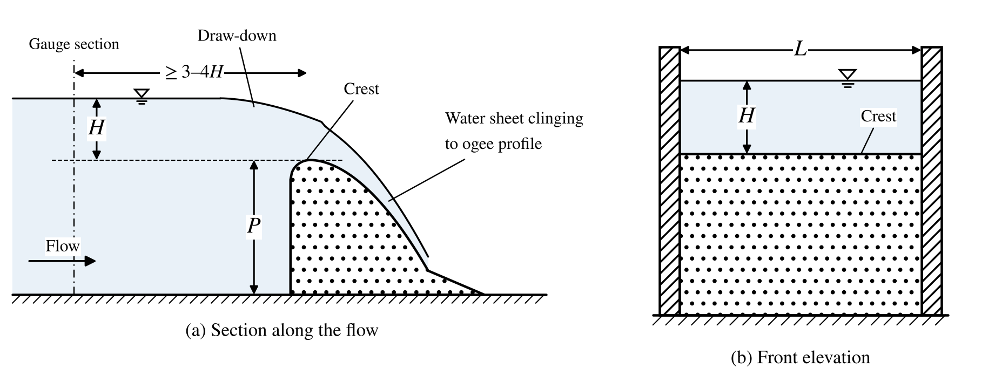
Figure 5: Ogee weir – head H over the crest, crest height P and crest length L
The discharge over an ogee weir is governed by the head $H$ measured above the crest at a section upstream (at least 3–4 H) where the water surface is not drawn down. Treating the weir as a rectangular overflow of crest length $L$:
$$Q_{th}=\frac{2}{3}L\sqrt{2g} H^{3/2}$$
$$Q_{act}=C_{d}\frac{2}{3}L\sqrt{2g} H^{3/2} ⇒ C_{d}=\frac{Q_{act}}{Q_{th}}$$
The coefficient of discharge depends on the ratio of the actual head to the design head, the height of the weir above the bed, the upstream face slope and submergence; for an ogee weir it is usually higher than that of a sharp-crested weir.

3.4 Apparatus
- Ogee weir model fixed in the flume with regulated water supply
- Pointer gauge for measuring the head over the crest
- Measuring tank with piezometer and graduated scale
- Stopwatch
- Scale / vernier caliper for measuring the crest length L

3.5 Data
- Area of measuring tank, $A$ = 0.2 m²
- Crest length of the weir (width of flume), $L$ = ________________ m

3.6 Experimental Procedure
- Fix the ogee weir model in the flume. Measure and record the crest length L.
- Allow water to fill the flume up to the crest level and note the pointer gauge reading h₁ (crest reading).
- Open the inlet valve so that water flows over the weir. Wait until the flow becomes steady.
- Note the water-surface reading h₂ with the pointer gauge, at a section upstream of the weir. The head H = h₂ − h₁.
- Collect the water in the measuring tank and note the time t for a known rise R.
- Repeat steps 3–5 for at least four different discharges.

3.7 Observations
Table 5: Readings – ogee weir
Sl. No. | Valve opening | Head of water over crest |  |  |  | Collection of water discharged
Sl. No. | Valve opening | Initial h₁ (mm) | Final h₂ (mm) | h = h₂ − h₁ (mm) | H (m) | Rise R (mm) | Time t (s)
1 | ¼ opening
2 | ½ opening
3 | ¾ opening
4 | Full opening

3.8 Specimen Calculations
1. Actual discharge
$$Q_{act}=\frac{A× R}{t}= .............................. m^{3}/s$$
2. Theoretical discharge
$$Q_{th}=\frac{2}{3}L\sqrt{2g} H^{3/2}= .............................. m^{3}/s$$
3. Coefficient of discharge
$$C_{d}=\frac{Q_{act}}{Q_{th}}= ....................$$
Table 6: Calculations – ogee weir
Sl. No. | Valve opening | Actual discharge Q_{act} (m³/s) | Theoretical discharge Q_{th} (m³/s) | Coefficient of discharge C_{d}
1 | ¼ opening
2 | ½ opening
3 | ¾ opening
4 | Full opening
$$C_{d,avg}=\frac{Σ C_{d}}{4}= ....................$$

3.9 Graphs
- Plot $Q_{act}$ versus $H$ and $C_{d}$ versus $H$.

3.10 Precautions
- Ensure steady flow conditions before taking measurements.
- Measure the head H accurately from the weir crest, at a section clear of the drawdown.
- Minimise turbulence at the weir crest to ensure smooth flow.

3.11 Sources of Error
- Errors in head measurement due to meniscus or parallax.
- Inaccurate time measurement with the stopwatch.
- Unsteady flow due to variations in the water supply.

3.12 Applications
Ogee weirs are widely used in spillway design and flood-control structures, where precise flow measurement is essential for hydraulic efficiency and safety.

3.13 Result
The coefficient of discharge of the ogee weir has been determined at different discharges.
The average coefficient of discharge of the ogee weir, C_{d} = ________________

3.14 Conclusion
Discuss any discrepancies between theoretical and actual discharge values, along with possible reasons affecting C_{d}.

Signature of Faculty

Rough Work

Viva Voce Questions
- What is an ogee weir, and where is it typically used?
- How does an ogee weir differ from other types of weirs (e.g., broad crested or sharp crested)?
- What is the principle behind the flow measurement in an ogee weir?
- How does the shape of the ogee crest affect the flow characteristics?
- What is the equation used to calculate discharge over an ogee weir?
- Why is calibration of an ogee weir necessary?
- How do you measure the head over the ogee weir in the experiment?
- What is the importance of the tailwater condition in the calibration of an ogee weir?
- How is the discharge coefficient (Cd) determined for an ogee weir?
- What factors influence the discharge coefficient in an ogee weir?
- What is the typical flow range for an ogee weir, and how does it affect calibration?
- How do you calculate the flow rate using the head and discharge coefficient?
- How does the weir’s length impact the discharge measurement?
- What equipment is used to measure the flow rate and head in the ogee weir experiment?
- What is the effect of submergence on the accuracy of flow measurement in an ogee weir?
- How does the downstream water level affect the performance of the ogee weir?
- How do you determine the coefficient of discharge (Cd) experimentally?
- How does the velocity of approach affect the calibration of the ogee weir?
- What precautions should be taken to minimize measurement errors in this experiment?
- How does the shape and size of the ogee crest impact the flow characteristics and calibration?
- What are the common sources of error when calibrating an ogee weir?
- How does the angle of the ogee crest influence the flow rate?
- Why might the experimentally determined discharge differ from the theoretical discharge?
- What is the effect of water temperature on the discharge over an ogee weir?
- How do you measure the head difference across the ogee weir during the experiment?
- How is the performance curve for the ogee weir plotted, and what does it represent?
- How does the water depth in the approach channel affect the calibration of an ogee weir?
- Why is it important to ensure that the ogee weir crest is smooth and free of debris?
- What assumptions are made when using the equation for flow over an ogee weir?
- How would you use the calibration data to predict flow rates in practical applications?

Date: | Broad-Crested Weir

4 Calibration of Broad-Crested Weir

4.1 Aim of the Experiment
To determine the coefficient of discharge (C_{d}) of a given broad-crested weir.

4.2 Objective
To experimentally determine the coefficient of discharge of a broad-crested weir by measuring the head over the crest and the flow rate, and to obtain its calibration curve.

4.3 Theory
A broad-crested weir has a horizontal crest long enough in the direction of flow (crest length $B > 2.5H$ approximately) for the streamlines to become parallel over it, so that the pressure distribution on the crest is hydrostatic. The flow passes through critical depth on the crest, which makes the weir a convenient flow-measuring device in open channels.
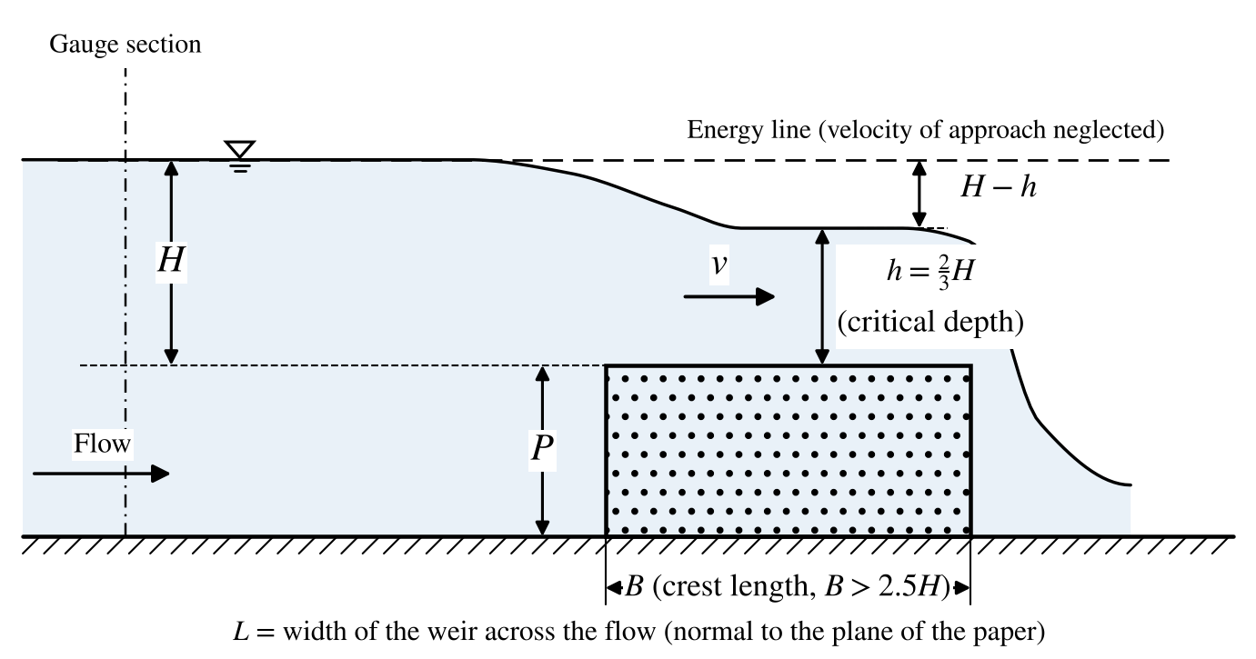
Figure 6: Broad-crested weir – head H, depth h over the crest, crest length B and width L
Let $H$ be the head over the crest measured upstream and $h$ the depth of flow over the crest. Neglecting the velocity of approach, the velocity on the crest is $v=\sqrt{2g(H-h)}$ and
$$Q=L h\sqrt{2g(H-h)}$$
The discharge is a maximum when $\frac{dQ}{dh}=0$, i.e. when $h=\frac{2}{3}H$ (critical depth). Substituting,
$$Q_{th}=L\sqrt{g}{\left(\frac{2}{3}H\right)}^{3/2}=1.705 L H^{3/2} (SI units)$$
$$Q_{act}=1.705 C_{d} L H^{3/2} ⇒ C_{d}=\frac{Q_{act}}{Q_{th}}$$
where $L$ = width of the weir across the flow (m) and $H$ = head over the crest (m).

4.4 Apparatus
- Broad-crested weir model fixed in the flume with regulated water supply
- Pointer gauge for measuring the head over the crest
- Measuring tank with piezometer and graduated scale
- Stopwatch
- Scale / vernier caliper

4.5 Data
- Area of measuring tank, $A$ = 0.2 m²
- Width of the weir (across flow), $L$ = ________________ m
- Length of the crest (in the direction of flow), $B$ = ________________ m

4.6 Experimental Procedure
- Fix the broad-crested weir in the flume and record its width L and crest length B.
- Allow water to fill up to the crest level and note the pointer gauge reading h₁.
- Open the inlet valve so that water flows over the weir and allow the flow to become steady.
- Note the upstream water-surface reading h₂; the head H = h₂ − h₁.
- Collect the water in the measuring tank and note the time t for a known rise R.
- Repeat steps 3–5 for at least four different discharges.

4.7 Observations
Table 7: Readings – broad-crested weir
Sl. No. | Valve opening | Head of water over crest |  |  |  | Collection of water discharged
Sl. No. | Valve opening | Initial h₁ (mm) | Final h₂ (mm) | h = h₂ − h₁ (mm) | H (m) | Rise R (mm) | Time t (s)
1 | ¼ opening
2 | ½ opening
3 | ¾ opening
4 | Full opening

4.8 Specimen Calculations
1. Actual discharge
$$Q_{act}=\frac{A× R}{t}= .............................. m^{3}/s$$
2. Theoretical discharge
$$Q_{th}=1.705 L H^{3/2}= .............................. m^{3}/s$$
3. Coefficient of discharge
$$C_{d}=\frac{Q_{act}}{Q_{th}}= ....................$$
Table 8: Calculations – broad-crested weir
Sl. No. | Valve opening | Actual discharge Q_{act} (m³/s) | Theoretical discharge Q_{th} (m³/s) | Coefficient of discharge C_{d}
1 | ¼ opening
2 | ½ opening
3 | ¾ opening
4 | Full opening
$$C_{d,avg}=\frac{Σ C_{d}}{4}= ....................$$

4.9 Graphs
- Plot $Q_{act}$ versus $H$ and $C_{d}$ versus $H$.

4.10 Precautions
- Ensure steady flow conditions before taking measurements.
- Measure the head H accurately from the crest.
- Minimise turbulence at the weir crest to ensure smooth flow.
- Make sure the weir is not submerged by tail water.

4.11 Sources of Error
- Errors in head measurement due to meniscus or parallax.
- Inaccurate time measurement with the stopwatch.
- Unsteady flow due to variations in the water supply.

4.12 Applications
Broad-crested weirs are commonly used in open channels for flow measurement and water regulation, particularly in river engineering and irrigation systems.

4.13 Result
The coefficient of discharge of the broad-crested weir has been determined at different discharges.
The average coefficient of discharge of the broad-crested weir, C_{d} = ________________

4.14 Conclusion
Discuss any discrepancies between theoretical and actual discharge values, along with possible reasons affecting C_{d}.

Signature of Faculty

Rough Work

Viva Voce Questions
- What is a broad crested weir, and where is it commonly used?
- How does a broad crested weir differ from a sharp-crested weir?
- What principle does a broad crested weir operate on for flow measurement?
- How is the flow rate determined using a broad crested weir?
- What is the equation used to calculate flow over a broad crested weir?
- Why is calibration of a broad crested weir necessary?
- What factors affect the discharge over a broad crested weir?
- How does the width of the weir crest affect the discharge?
- How is the head over the weir measured in the experiment?
- What is the purpose of measuring the water level upstream of the weir?
- How do you calculate the flow rate in a broad crested weir using experimental data?
- What is the significance of the flow coefficient (Cd) for a broad crested weir?
- How do you determine the coefficient of discharge (Cd) for a broad crested weir from experimental data?
- What equipment is used to measure the head and flow rate in this experiment?
- How does the shape of the weir crest (flat, curved) influence the discharge measurement?
- What are the primary sources of error in the calibration of a broad crested weir?
- How does the approach velocity affect the accuracy of flow measurement over a broad crested weir?
- How do you minimize errors caused by turbulence or velocity profile distortion in the flow approaching the weir?
- How is the effect of downstream conditions considered in this experiment?
- How does the slope of the weir affect the flow rate?
- How would you determine the flow rate from the head measurements using the calibration curve?
- What role does the weir’s length play in determining the flow rate?
- Why might the actual discharge differ from the theoretical discharge in a broad crested weir?
- How do you calculate the flow coefficient (Cd) for different flow rates?
- How does water temperature affect the calibration of a broad crested weir?
- Why is it important to ensure that the weir is free from debris or obstructions during the experiment?
- What assumptions are made in the theoretical equation for flow over a broad crested weir?
- How would you calculate the error margin in the discharge measurement for a broad crested weir?
- How does the depth of flow (submergence) influence the accuracy of the weir’s flow measurement?
- What are the practical applications of broad crested weirs in civil engineering and hydrology?

Date: | Venturi-meter

5 Calibration of Venturi-meter

5.1 Aim of the Experiment
To demonstrate the use of a venturi-meter as a flow meter and to determine its coefficient of discharge (C_{d}).

5.2 Objective
To experimentally determine the coefficient of discharge of a given venturi-meter for fluid flowing through a pipeline, by comparing the actual discharge with the theoretical discharge obtained from the measured differential head.

5.3 Theory
A venturi-meter is a device used for measuring the rate of flow of a fluid through a pipeline. Its working principle is that, by reducing the cross-sectional area of the flow passage, a pressure difference is created between the inlet and the throat; measurement of this pressure difference enables the discharge to be determined (an application of Bernoulli’s equation).
A venturi-meter consists of (i) an inlet section of the same diameter as the pipe followed by a convergent cone, (ii) a short cylindrical throat, and (iii) a gradually divergent cone that restores the original pipe diameter. Pressure tappings are provided at the inlet and at the throat through pressure rings. Because the divergence is gradual, the energy loss is small and C_{d} is high (typically 0.95–0.99).
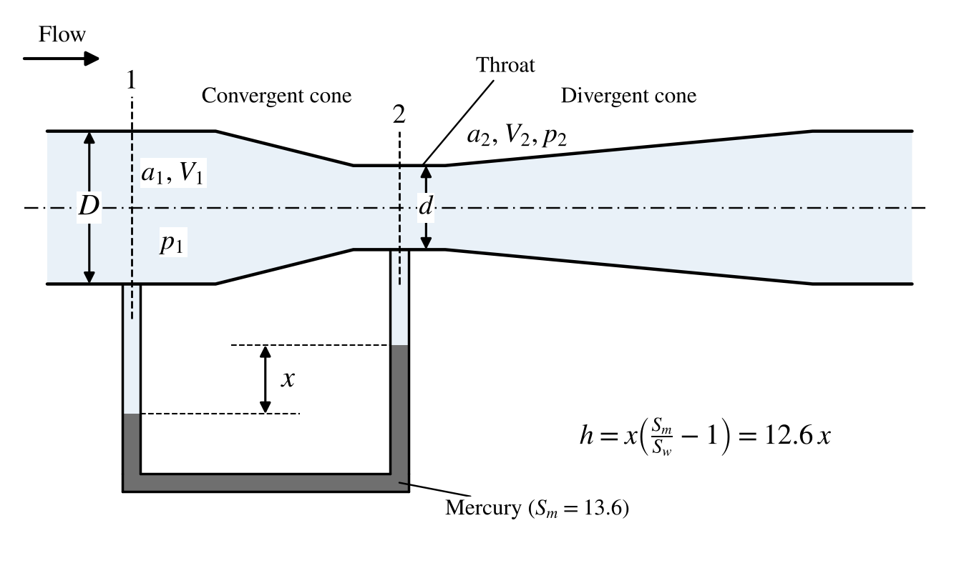
Figure 7: Venturi-meter – inlet section 1, throat section 2 and differential manometer reading x
Applying Bernoulli’s equation between the inlet (1) and the throat/orifice (2), together with continuity, the theoretical discharge is
$$Q_{th}=\frac{a_{1}a_{2}\sqrt{2gh}}{\sqrt{a_{1}^{2}-a_{2}^{2}}}$$
where $a_{1}$ = area of the inlet pipe (m²), $a_{2}$ = area of the throat (m²) and $h$ = differential head in metres of water. For a mercury–water differential manometer reading $x$:
$$h=x\left(\frac{S_{m}}{S_{w}}-1\right)=x\left(13.6-1\right)=12.6 x$$
$$C_{d}=\frac{Q_{act}}{Q_{th}}$$

5.4 Apparatus
- Pipeline with a venturi-meter
- Tappings with ball valves at the inlet and throat of the venturi-meter, connected to a differential (U-tube) mercury manometer
- Constant steady supply of water from a monobloc pump, with a valve for varying the flow rate
- Measuring tank with piezometer and scale to measure the flow rate
- Stopwatch (or electronic digital timer with float switch, if provided)

5.5 Data
- Area of measuring tank, $A$ = 0.12 m²
- Diameter of the inlet pipe, $D$ = 25 mm
- Diameter of the throat, $d$ = 12.5 mm
- Acceleration due to gravity, $g$ = 9.81 m/s²
- Specific gravity of mercury, $S_{m}$ = 13.6

5.6 Experimental Procedure
- Select the required venturi-meter and note the diameters at the inlet and throat.
- Start the pump, open the flow-control valve and allow a certain discharge through the pipeline.
- Open the ball valves of the tappings and remove air bubbles from the manometer limbs using the air-vent valves.
- When the flow is steady, note the levels h₁ and h₂ in the two limbs of the manometer.
- Close the drain valve of the measuring tank and note the time t for a known rise R of water level (say 100 mm).
- Repeat steps 4–5 for different valve openings (at least four trials).

5.7 Observations
Table 9: Readings – venturi-meter
Sl. No. | Valve opening | Manometer reading |  |  |  | Collection of water
Sl. No. | Valve opening | Left limb h₁ (mm) | Right limb h₂ (mm) | x = h₁ − h₂ (mm of Hg) | h = 12.6x/1000 (m of water) | Rise R (mm) | Time t (s)
1 | ¼ opening
2 | ½ opening
3 | ¾ opening
4 | Full opening

5.8 Specimen Calculations
1. Areas
$$a_{1}=\frac{π D^{2}}{4}= ......... m^{2}, a_{2}=\frac{π d^{2}}{4}= ......... m^{2}$$
2. Theoretical discharge
$$Q_{th}=\frac{a_{1}a_{2}\sqrt{2gh}}{\sqrt{a_{1}^{2}-a_{2}^{2}}}= .............................. m^{3}/s$$
3. Actual discharge
$$Q_{act}=\frac{A× R}{t}= .............................. m^{3}/s$$
where $A$ = area of measuring tank (m²), $R$ = rise of water level (m), $t$ = time taken (s).
4. Coefficient of discharge
$$C_{d}=\frac{Q_{act}}{Q_{th}}= ....................$$
Table 10: Calculations – venturi-meter
Sl. No. | Valve opening | h (m of water) | Theoretical discharge Q_{th} (m³/s) | Actual discharge Q_{act} (m³/s) | Coefficient of discharge C_{d}
1 | ¼ opening
2 | ½ opening
3 | ¾ opening
4 | Full opening
$$C_{d,avg}=\frac{Σ C_{d}}{4}= ....................$$

5.9 Graphs
- Plot $Q_{act}$ versus $\sqrt{h}$ (should be a straight line through the origin; slope = $C_{d}K$).
- Plot $C_{d}$ versus $Q_{act}$.

5.10 Precautions
- Ensure there are no leaks in the setup.
- Ensure steady flow conditions before taking measurements.
- Remove all air bubbles from the manometer limbs.
- Open the manometer ball valves slowly so that mercury is not blown out.
- Use an accurate stopwatch to time the collection of water.

5.11 Sources of Error
- Parallax error in reading manometer levels.
- Unsteady flow rate due to fluctuations in water supply.
- Errors in measuring the time of collection.
- Minor leakage from the setup.

5.12 Applications
Venturi-meters are used in industries for accurate flow measurement of fluids – in water supply, chemical processing, water treatment, and the oil and gas industries – where low head loss is important.

5.13 Result
The coefficient of discharge of the given venturi-meter has been determined.
The average coefficient of discharge, C_{d} = ________________

5.14 Conclusion
Discuss the factors affecting the coefficient of discharge of the venturi-meter and the significance of any discrepancies between theoretical and actual values.

Signature of Faculty

Rough Work

Viva Voce Questions
- What is a Venturi meter, and where is it commonly used?
- What principle does the Venturi meter operate on?
- What are the main components of a Venturi meter?
- How does a Venturi meter measure flow rate?
- What is the coefficient of discharge (Cd) in a Venturi meter?
- Why is calibration of a Venturi meter necessary?
- What is the purpose of the converging and diverging sections in a Venturi meter?
- How does the Venturi meter create a differential pressure?
- How do you calculate the theoretical flow rate in a Venturi meter?
- How is the actual flow rate determined in the experiment?
- How do you calculate the coefficient of discharge (Cd) from experimental data?
- Why is the coefficient of discharge usually less than 1?
- What is the relationship between pressure difference and flow rate in a Venturi meter?
- How does Reynolds number affect the performance of a Venturi meter?
- What is the formula to calculate the Reynolds number for flow in a Venturi meter?
- What equipment is used to measure the differential pressure in a Venturi meter experiment?
- Why is the Venturi meter more accurate than an orifice meter?
- How does fluid viscosity affect the accuracy of a Venturi meter?
- How does the diameter ratio (throat to pipe diameter) affect the flow rate measurement?
- What are the primary sources of error in a Venturi meter experiment?
- Why is it important to have straight pipe lengths upstream and downstream of the Venturi meter?
- How does cavitation occur in a Venturi meter, and how can it be prevented?
- What is the vena contracta, and does it occur in a Venturi meter?
- How is the coefficient of discharge (Cd) affected by the flow conditions?
- How does temperature affect the readings of a Venturi meter?
- How would you explain the energy conversion that occurs in a Venturi meter?
- Why might there be a difference between the theoretical and actual flow rates in a Venturi meter?
- What is the purpose of using a manometer in the Venturi meter experiment?
- How does calibration improve the reliability of a Venturi meter in industrial applications?
- What are some advantages of using a Venturi meter over other flow measurement devices?

Date: | Orifice-meter

6 Calibration of Orifice-meter

6.1 Aim of the Experiment
To determine the coefficient of discharge (C_{d}) of a given orifice-meter.

6.2 Objective
To experimentally determine the coefficient of discharge of a given orifice-meter for fluid flowing through a pipeline, by comparing the actual discharge with the theoretical discharge obtained from the measured differential head.

6.3 Theory
An orifice-meter is a device used for measuring the rate of flow of a liquid through a pipe. It is cheaper than a venturi-meter and works on the same principle (Bernoulli’s equation). It consists of a flat circular plate with a sharp-edged circular hole (orifice) concentric with the pipe. The orifice diameter is generally about 0.5 times the pipe diameter, though it may vary from 0.4 to 0.8 times.
One pressure tapping is located 1.5 to 2 pipe diameters upstream of the plate, and the other about half a pipe diameter downstream, near the vena contracta, where the converging jet has its minimum area and therefore its maximum velocity and minimum pressure. Because of the sudden contraction and expansion, energy losses are large and C_{d} is low (typically 0.6–0.65).
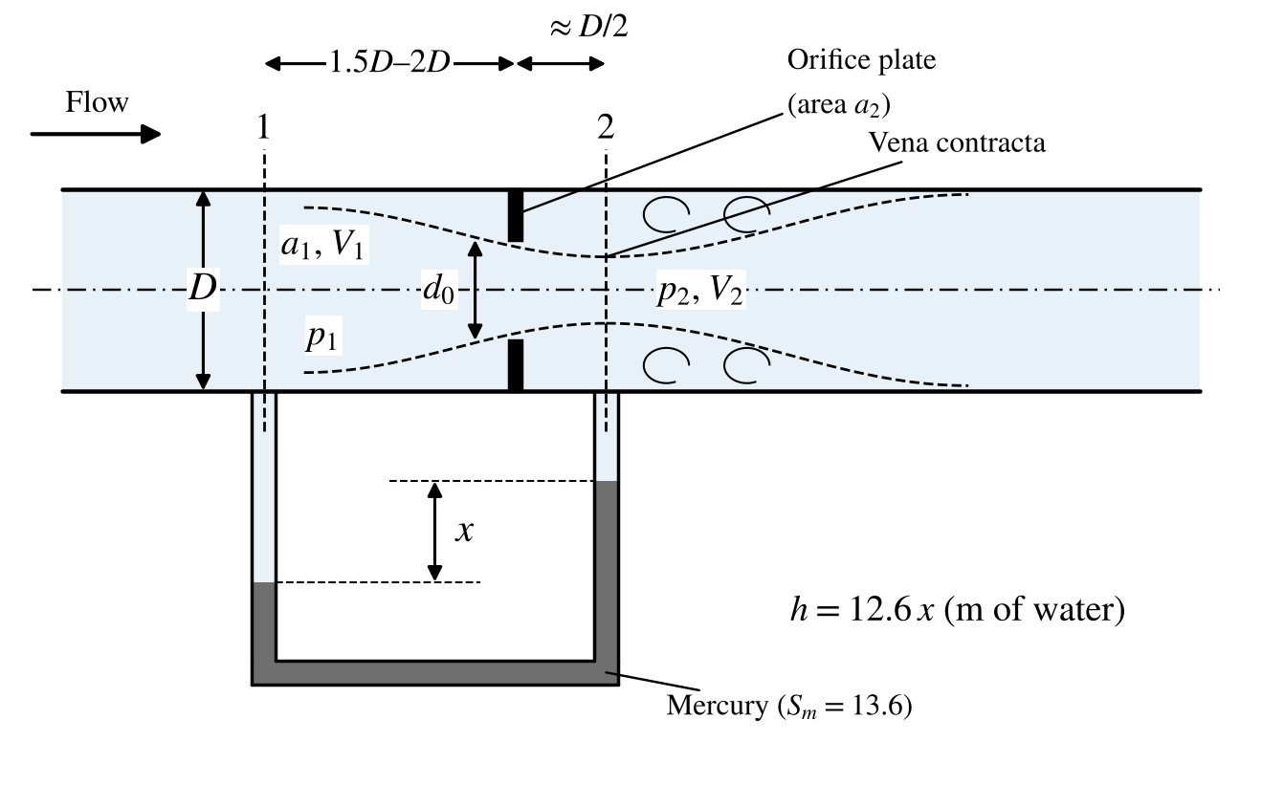
Figure 8: Orifice-meter – pipe section 1, orifice plate, vena contracta section 2 and manometer reading x
Applying Bernoulli’s equation between the inlet (1) and the throat/orifice (2), together with continuity, the theoretical discharge is
$$Q_{th}=\frac{a_{1}a_{2}\sqrt{2gh}}{\sqrt{a_{1}^{2}-a_{2}^{2}}}$$
where $a_{1}$ = area of the inlet pipe (m²), $a_{2}$ = area of the orifice (m²) and $h$ = differential head in metres of water. For a mercury–water differential manometer reading $x$:
$$h=x\left(\frac{S_{m}}{S_{w}}-1\right)=x\left(13.6-1\right)=12.6 x$$
$$C_{d}=\frac{Q_{act}}{Q_{th}}$$

6.4 Apparatus
- Pipeline with an orifice-meter, connected to a differential (U-tube) mercury manometer
- Regulated water supply arrangement with a valve for varying the flow rate
- Measuring tank fitted with a piezometer tube and graduated scale
- Stopwatch

6.5 Data
- Area of measuring tank, $A$ = 0.12 m²
- Diameter of the inlet pipe, $D$ = 25 mm
- Diameter of the orifice, $d$ = 12.5 mm
- Acceleration due to gravity, $g$ = 9.81 m/s²
- Specific gravity of mercury, $S_{m}$ = 13.6

6.6 Experimental Procedure
- Select the required orifice-meter and note the diameters at the inlet and orifice.
- Start the pump, open the flow-control valve and allow a certain discharge through the pipeline.
- Open the ball valves of the tappings and remove air bubbles from the manometer limbs using the air-vent valves.
- When the flow is steady, note the levels h₁ and h₂ in the two limbs of the manometer.
- Close the drain valve of the measuring tank and note the time t for a known rise R of water level (say 100 mm).
- Repeat steps 4–5 for different valve openings (at least four trials).

6.7 Observations
Table 11: Readings – orifice-meter
Sl. No. | Valve opening | Manometer reading |  |  |  | Collection of water
Sl. No. | Valve opening | Left limb h₁ (mm) | Right limb h₂ (mm) | x = h₁ − h₂ (mm of Hg) | h = 12.6x/1000 (m of water) | Rise R (mm) | Time t (s)
1 | ¼ opening
2 | ½ opening
3 | ¾ opening
4 | Full opening

6.8 Specimen Calculations
1. Areas
$$a_{1}=\frac{π D^{2}}{4}= ......... m^{2}, a_{2}=\frac{π d^{2}}{4}= ......... m^{2}$$
2. Theoretical discharge
$$Q_{th}=\frac{a_{1}a_{2}\sqrt{2gh}}{\sqrt{a_{1}^{2}-a_{2}^{2}}}= .............................. m^{3}/s$$
3. Actual discharge
$$Q_{act}=\frac{A× R}{t}= .............................. m^{3}/s$$
where $A$ = area of measuring tank (m²), $R$ = rise of water level (m), $t$ = time taken (s).
4. Coefficient of discharge
$$C_{d}=\frac{Q_{act}}{Q_{th}}= ....................$$
Table 12: Calculations – orifice-meter
Sl. No. | Valve opening | h (m of water) | Theoretical discharge Q_{th} (m³/s) | Actual discharge Q_{act} (m³/s) | Coefficient of discharge C_{d}
1 | ¼ opening
2 | ½ opening
3 | ¾ opening
4 | Full opening
$$C_{d,avg}=\frac{Σ C_{d}}{4}= ....................$$

6.9 Graphs
- Plot $Q_{act}$ versus $\sqrt{h}$ (should be a straight line through the origin; slope = $C_{d}K$).
- Plot $C_{d}$ versus $Q_{act}$.

6.10 Precautions
- Ensure there are no leaks in the setup.
- Ensure steady flow conditions before taking measurements.
- Remove all air bubbles from the manometer limbs.
- Open the manometer ball valves slowly so that mercury is not blown out.
- Use an accurate stopwatch to time the collection of water.

6.11 Sources of Error
- Parallax error in reading manometer levels.
- Unsteady flow rate due to fluctuations in water supply.
- Errors in measuring the time of collection.
- Minor leakage from the setup.

6.12 Applications
Orifice-meters are commonly used in industrial applications for measuring the flow rate of liquids, gases and steam, making them essential for process control and monitoring systems.

6.13 Result
The coefficient of discharge of the given orifice-meter has been determined.
The average coefficient of discharge, C_{d} = ________________

6.14 Conclusion
Discuss the factors affecting the coefficient of discharge of the orifice-meter and the significance of any discrepancies between theoretical and actual values (compare with the venturi-meter).

Signature of Faculty

Rough Work

Viva Voce Questions
- What is an orifice meter, and where is it commonly used?
- How does an orifice meter measure flow rate?
- What is the principle behind an orifice meter?
- Define the coefficient of discharge (Cd) for an orifice meter.
- Why is calibration of an orifice meter necessary?
- How does the orifice plate create a differential pressure?
- What is the vena contracta in an orifice meter?
- How do you calculate the theoretical flow rate in an orifice meter?
- What is the formula for actual discharge through an orifice meter?
- How do you determine the coefficient of discharge (Cd) from experimental data?
- What equipment is used to measure differential pressure in the orifice meter experiment?
- How is the actual flow rate determined in the experiment?
- What factors affect the coefficient of discharge in an orifice meter?
- Why is the coefficient of discharge usually less than 1?
- How does the diameter of the orifice affect the flow rate measurement?
- What is the effect of fluid viscosity on the orifice meter’s accuracy?
- What precautions should be taken to ensure accurate calibration of the orifice meter?
- What are the primary sources of error in an orifice meter experiment?
- How does Reynolds number affect the coefficient of discharge?
- How do you calculate the Reynolds number for flow through an orifice meter?
- What is the relationship between the pressure drop and flow rate in an orifice meter?
- Why is it important to install the orifice plate correctly in the pipeline?
- What is the purpose of the tapping points in an orifice meter setup?
- How does upstream and downstream pipe length affect orifice meter performance?
- Why might the experimentally determined flow rate differ from the theoretical value?
- How does temperature affect the readings of an orifice meter?
- What is the Bernoulli’s equation and how is it applied in the orifice meter?
- How does cavitation occur in an orifice meter, and how can it be avoided?
- What is the advantage of using an orifice meter over other flow measuring devices?
- How does calibration improve the reliability of the orifice meter in practical applications?

Date: | Vertical Orifice

7 Determination of the Hydraulic Coefficients of a Vertical Orifice

7.1 Aim of the Experiment
To determine the hydraulic coefficients – the coefficient of velocity (C_{v}), the coefficient of discharge (C_{d}) and the coefficient of contraction (C_{c}) – of a vertical orifice.

7.2 Objective
To determine the hydraulic coefficients of a vertical orifice under a constant head, using the trajectory of the jet to find the actual velocity and the measuring tank to find the actual discharge.

7.3 Theory
A vertical orifice is a small opening in the vertical side of a tank through which liquid flows owing to the pressure head. As the liquid issues from a sharp-edged orifice, the jet contracts to a minimum area at a short distance downstream called the vena contracta. The hydraulic coefficients account for these non-idealities:
- Coefficient of velocity $C_{v}=\frac{v_{actual}}{v_{th}}$ – accounts for friction (typically 0.95–0.99).
- Coefficient of contraction $C_{c}=\frac{a_{c}}{a}$ – ratio of the jet area at the vena contracta to the orifice area (typically 0.61–0.69).
- Coefficient of discharge $C_{d}=\frac{Q_{act}}{Q_{th}}=C_{c}× C_{v}$ (typically 0.61–0.65).

Coefficient of velocity from the jet trajectory
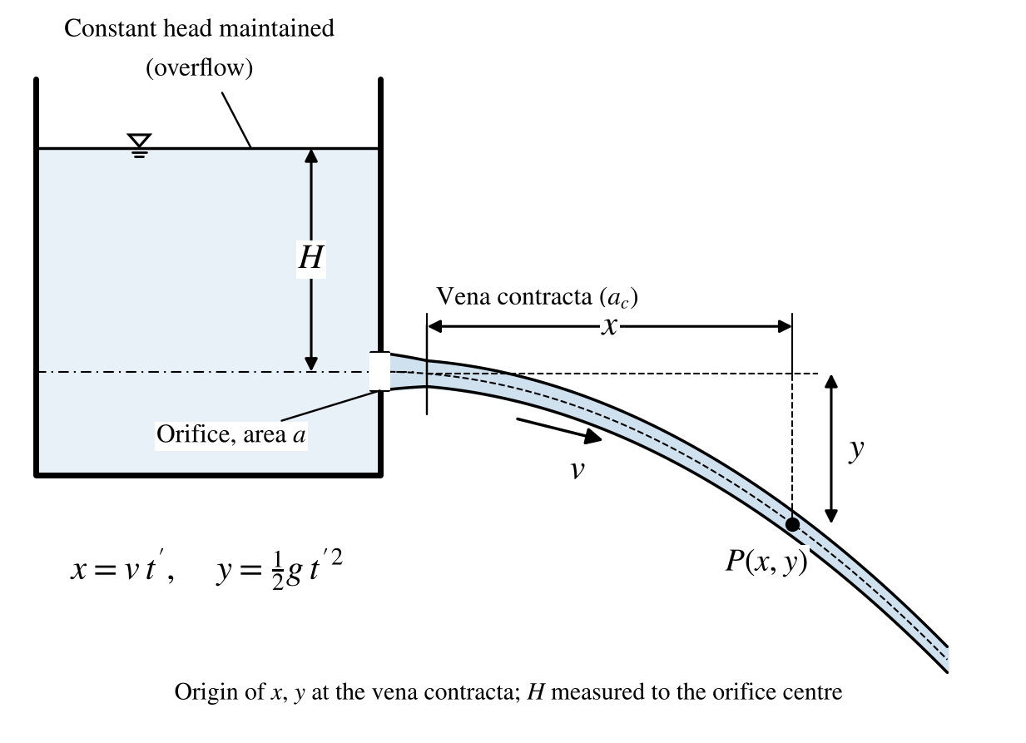
Figure 9: Vertical orifice – constant head H, vena contracta and jet co-ordinates (x, y)
Let a particle of the jet travel a horizontal distance $x$ and fall a vertical distance $y$ from the vena contracta in time $t'$. Then
$$x=v t', y=\frac{1}{2}g t'^{2}$$
Eliminating $t'$:
$$v_{actual}=\sqrt{\frac{g x^{2}}{2y}}$$
Since the theoretical velocity is $v_{th}=\sqrt{2gH}$,
$$C_{v}=\frac{v_{actual}}{v_{th}}=\frac{x}{\sqrt{4yH}}$$

Coefficient of discharge and contraction
$$C_{d}=\frac{Q_{act}}{Q_{th}}=\frac{A R/t}{a\sqrt{2gH}}$$
$$C_{c}=\frac{C_{d}}{C_{v}}$$
where $a$ = area of the orifice (m²), $H$ = constant head measured from the centre of the orifice (m), $A$ = area of the collecting tank (m²), $R$ = rise of water in the collecting tank (m) and $t$ = time for rise $R$ (s).

7.4 Apparatus
- Orifice plate fitted to the side of a supply tank
- Piezometer to measure the constant head H
- Hook-gauge arrangement with horizontal and movable vertical scales to measure the jet coordinates (x, y) from the vena contracta
- Collecting tank fitted with piezometer to determine the actual discharge
- Stopwatch

7.5 Data
- Diameter of the orifice, $d$ = ________________ mm
- Area of the collecting tank, $A$ = ________________ m²

7.6 Experimental Procedure
- Note down the dimensions of the collecting tank and the diameter of the orifice.
- Switch on the pump connected to the orifice setup.
- Allow water to flow and maintain a constant head H in the supply tank; note H from the piezometer.
- Measure the horizontal distance x and the vertical distance y of a point on the jet from the vena contracta using the horizontal and movable vertical scales.
- Allow the water to flow into the collecting tank and note the time t for a rise of R (say 10 cm).
- Repeat steps 3–5 for different heads (at least four trials).

7.7 Observations
Table 13: Readings – vertical orifice
Sl. No. | Constant head H (m) | Horizontal distance x (m) | Vertical distance y (m) | Rise in collecting tank R (m) | Time for rise R, t (s)
1
2
3
4
5

7.8 Specimen Calculations
$$C_{v}=\frac{x}{\sqrt{4yH}}= ....................$$
$$Q_{act}=\frac{A R}{t}= .................... m^{3}/s, Q_{th}=a\sqrt{2gH}= .................... m^{3}/s$$
$$C_{d}=\frac{Q_{act}}{Q_{th}}= ...................., C_{c}=\frac{C_{d}}{C_{v}}= ....................$$
Table 14: Calculations – vertical orifice
Sl. No. | C_{v} = x/√(4yH) | Q_{act} = AR/t (m³/s) | Q_{th} = a√(2gH) (m³/s) | C_{d} | C_{c} = C_{d}/C_{v} | Remarks
1
2
3
4
5

7.9 Graphs
- Plot $Q_{act}$ versus $\sqrt{H}$; the slope gives $C_{d}a\sqrt{2g}$.
- Plot $x$ versus $\sqrt{yH}$; the slope gives $2C_{v}$.

7.10 Precautions
- Maintain a constant head during each trial.
- Measure the head from the centre of the orifice.
- Take the jet coordinates carefully without disturbing the jet.
- Avoid air bubbles in the piezometer.

7.11 Sources of Error
- Parallax error in reading the water levels and jet coordinates.
- Inaccurate measurement of the orifice diameter.
- Minor fluctuations in the water head.

7.12 Applications
Orifices are used in fluid mechanics and hydraulic engineering for flow measurement and control – tank outlets, sluices, spillway outlets, water-jet studies and flow-control systems in reservoirs and tanks.

7.13 Result
Average coefficient of velocity, C_{v} = ________________
Average coefficient of discharge, C_{d} = ________________
Average coefficient of contraction, C_{c} = ________________

7.14 Conclusion
Discuss the values of the hydraulic coefficients obtained, their variation with head, and the effect of the sharpness of the orifice edge.

Signature of Faculty

Rough Work

Viva Voce Questions
- What is an orifice, and where is it commonly used?
- What is the purpose of determining the hydraulic coefficient of an orifice?
- What are the three main hydraulic coefficients associated with an orifice?
- Define the coefficient of discharge (Cd) for an orifice.
- Define the coefficient of velocity (Cv) for an orifice.
- Define the coefficient of contraction (Cc) for an orifice.
- How is the coefficient of discharge (Cd) calculated?
- What is the relationship between Cd, Cv, and Cc?
- How does the size of the orifice affect the hydraulic coefficients?
- How does the shape of the orifice affect the flow characteristics?
- Why is the coefficient of discharge typically less than 1?
- What equipment is used to measure the flow rate in this experiment?
- How is the theoretical discharge through an orifice calculated?
- How do you measure the actual discharge in the orifice experiment?
- What is the vena contracta, and why is it important in this experiment?
- How does the velocity of approach affect the discharge through an orifice?
- What is the formula for the velocity of water jetting from an orifice?
- How do you calculate the coefficient of velocity (Cv)?
- What factors can affect the value of the coefficient of contraction (Cc)?
- How does orifice diameter impact the discharge rate?
- What precautions should be taken to ensure accurate measurements?
- How does water head above the orifice affect the discharge?
- How do you calculate the head loss due to friction in the orifice setup?
- What are some common sources of error in this experiment?
- Why might there be a discrepancy between theoretical and actual discharge values?
- How does viscosity of the fluid affect the hydraulic coefficients?
- What is meant by a “sharp-edged” orifice, and why is it important?
- How would you measure the velocity at the vena contracta?
- What applications commonly use orifices for flow measurement?
- How do the hydraulic coefficients help in designing orifice-based flow systems?

Date: | Darcy’s Friction Factor

8 Determination of Darcy’s Friction Factor for a Straight Pipe

8.1 Aim of the Experiment
To determine the head loss due to friction in a straight pipe and hence the Darcy friction factor (f) for pipes of different diameters.

8.2 Objective
To determine the Darcy friction factor (f) for flow in straight pipes under different flow conditions and to analyse how it varies with velocity and Reynolds number.

8.3 Theory
When a fluid flows through a pipe, its internal roughness and the viscosity of the fluid offer resistance to the flow. The resulting loss of energy, expressed as head, is called the major loss or friction loss. Darcy’s friction factor f is a dimensionless quantity describing this resistance; it depends on the Reynolds number and the relative roughness of the pipe (Moody diagram).

Derivation of the Darcy–Weisbach equation
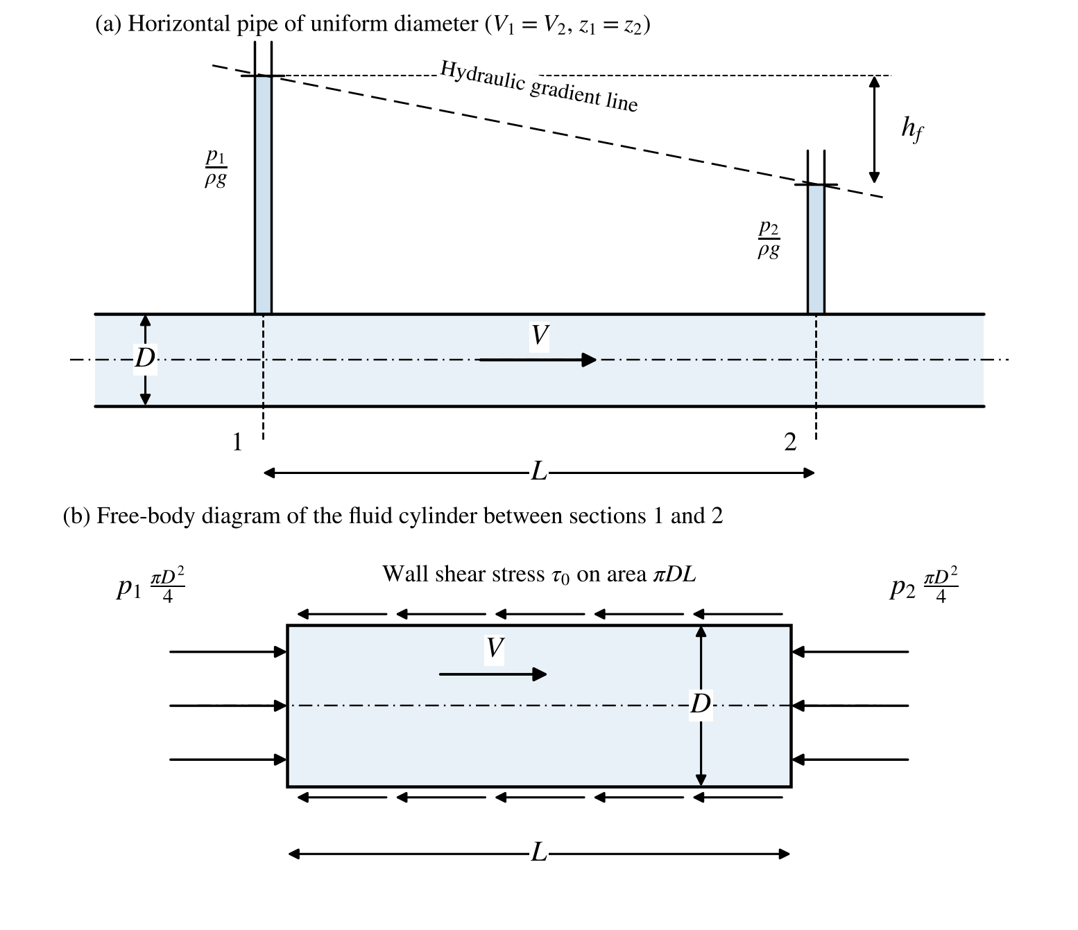
Figure 10: Pipe friction – (a) head loss hf over length L, (b) forces on the fluid cylinder
Applying Bernoulli’s equation between sections 1 and 2, a length L apart, in a horizontal pipe of uniform diameter ($V_{1}=V_{2}$, $z_{1}=z_{2}$):
$$\frac{p_{1}}{ρ g}+\frac{V_{1}^{2}}{2g}+z_{1}=\frac{p_{2}}{ρ g}+\frac{V_{2}^{2}}{2g}+z_{2}+h_{f} ⇒ h_{f}=\frac{p_{1}-p_{2}}{ρ g}$$
For equilibrium of the fluid between the two sections, the net pressure force balances the wall shear force:
$$(p_{1}-p_{2})\frac{π D^{2}}{4}=τ_{0} π D L$$
Experiments show that $τ_{0}=f'\frac{ρ V^{2}}{2}$, where $f'$ is the coefficient of friction (Fanning). Substituting,
$$h_{f}=\frac{4f'LV^{2}}{2gD}=\frac{f L V^{2}}{2g D} (f=4f')$$
Hence the Darcy friction factor is obtained from the measured head loss as
$$f=\frac{2g D h_{f}}{L V^{2}}$$
For laminar flow ($Re<2000$), $f=\frac{64}{Re}$; for turbulent flow in smooth pipes, $f=\frac{0.316}{Re^{1/4}}$ (Blasius, $Re<10^{5}$), where $Re=\frac{VD}{ν}$.

8.4 Apparatus
- Pipe-friction apparatus with pipelines of different diameters (½″, ¾″ and 1″ GI pipes; 1″ SS pipe)
- U-tube (double-column) mercury manometer connected across each pipeline with change-over (ball) valves
- Constant steady supply of water from a centrifugal pump with a valve for varying the flow rate
- Measuring tank with stop clock for measurement of flow rate
- Sump tank mounted below the collecting tank
- Butterfly valve for instantaneous dumping of collected water into the sump, and overflow pipe for closed-circuit operation

8.5 Specifications
- Pump capacity: 1 HP, single phase
- Collecting (measuring) tank area, $A$ = 0.12 m²
- Pipe internal diameters: 16 mm (½″ GI), 21 mm (¾″ GI), 27 mm (1″ GI); 1″ SS pipe also provided
- Length of pipe between pressure tappings, $L$ = ________________ m

8.6 Experimental Procedure
All the necessary instrumentation and accessories are readily connected. Follow the instructions below:
- Fill the sump tank with clean water.
- Keep the delivery valve closed.
- Connect the power cable to a 1-phase, 220 V, 10 A supply with earth connection.
- Switch ON the pump and open the delivery valve.
- Open the ball valve of the pipeline to be tested.
- Adjust the flow using the control valve of the pump.
- Open the corresponding manometer ball valves and expel any air by opening the air-vent valve on the manometer.
- Note the differential head reading on the manometer.
- Close the butterfly valve of the collecting tank and note the time for a known rise of water level; keep it open when readings are not being taken.
- Change the flow rate and repeat; then repeat the experiment for the other pipe diameters.

8.7 Observations
Table 15: Readings – pipe friction
Pipe | Valve opening | Rise in water level R (mm) | Time taken t (s) | Manometer h₁ – h₂ = H (mm of Hg) | Remarks
Ø 16 mm (½″ pipe) | Quarter opening | 100
Ø 16 mm (½″ pipe) | Half opening | 100
Ø 16 mm (½″ pipe) | Full opening | 100
Ø 21 mm (¾″ pipe) | Quarter opening | 100
Ø 21 mm (¾″ pipe) | Half opening | 100
Ø 21 mm (¾″ pipe) | Full opening | 100
Ø 27 mm (1″ pipe) | Quarter opening | 100
Ø 27 mm (1″ pipe) | Half opening | 100
Ø 27 mm (1″ pipe) | Full opening | 100

8.8 Specimen Calculations
1. Actual discharge
$$Q=\frac{A× R}{t}= ......................... m^{3}/s$$
2. Head loss due to friction
$$h_{f}=\frac{12.6 H}{1000}= ......................... m of water$$
where $H$ = difference in mercury columns (mm of Hg).
3. Velocity
$$V=\frac{Q}{a}, a=\frac{π d^{2}}{4} ⇒ V= .................... m/s$$
4. Darcy friction factor
$$f=\frac{2g d h_{f}}{L V^{2}}= ....................$$
5. Reynolds number (ν ≈ 1.0 × 10⁻⁶ m²/s at 20 °C)
$$Re=\frac{Vd}{ν}= ....................$$
Table 16: Calculations – pipe friction
Pipe | Valve opening | Discharge Q (m³/s) | Velocity V (m/s) | Head loss h_{f} (m) | Reynolds no. Re | Friction factor f
Ø 16 mm (½″ pipe) | Quarter opening
Ø 16 mm (½″ pipe) | Half opening
Ø 16 mm (½″ pipe) | Full opening
Ø 21 mm (¾″ pipe) | Quarter opening
Ø 21 mm (¾″ pipe) | Half opening
Ø 21 mm (¾″ pipe) | Full opening
Ø 27 mm (1″ pipe) | Quarter opening
Ø 27 mm (1″ pipe) | Half opening
Ø 27 mm (1″ pipe) | Full opening

8.9 Graphs
- Plot $h_{f}$ versus $V$ (or $log h_{f}$ versus $log V$) for each pipe.
- Plot $f$ versus $Re$ and compare with the Moody diagram.

8.10 Precautions
- Do not start the pump if the supply voltage is less than 180 V.
- Ensure correct electrical neutral and earth connections.
- Eliminate air bubbles from the manometer before taking readings.
- Ensure steady flow before taking readings and time the collection accurately.
- Grease/oil rotating parts periodically (at least once in three months) and use clean water, changed once in three months.
- Operate the unit for five minutes at least once a week to prevent clogging of moving parts.

8.11 Sources of Error
- Errors in reading the manometer.
- Unsteady flow or fluctuations in water supply.
- Timing inaccuracies during flow-rate measurement.

8.12 Applications
Darcy’s friction factor is fundamental in designing pipelines for water, oil, gas and other fluid transport systems, enabling accurate calculation of head loss and ensuring efficient fluid transport.

8.13 Result
The head loss due to friction (major loss) in pipes of different diameters has been determined.
Average Darcy friction factor: ½″ pipe f = ________________; ¾″ pipe f = ________________; 1″ pipe f = ________________

8.14 Conclusion
Discuss the relationship between the friction factor and flow rate (Reynolds number), noting the trends observed for the different pipe diameters and the flow regime (laminar or turbulent).

Signature of Faculty

Rough Work

Viva Voce Questions
- What is Darcy’s friction factor, and why is it important?
- How does the friction factor affect fluid flow in pipes?
- What is the difference between Darcy’s friction factor and Fanning’s friction factor?
- What is the Darcy-Weisbach equation, and how is it used?
- How do you define head loss due to friction in a pipe?
- What are the units of Darcy’s friction factor?
- How does pipe diameter influence the friction factor?
- What role does the length of the pipe play in determining head loss?
- How does fluid velocity affect the friction factor?
- What is the Reynolds number, and why is it significant in this experiment?
- How does the type of flow (laminar, transitional, or turbulent) affect the friction factor?
- What is the typical value of the friction factor for laminar flow?
- What is the significance of the Moody chart in fluid flow analysis?
- How do you calculate the head loss in a pipe using the friction factor?
- What is the formula to determine the Reynolds number for flow in a pipe?
- How is flow rate measured in the experiment?
- What equipment is used to measure pressure drop in this experiment?
- What factors can cause an increase in the friction factor?
- How does pipe roughness affect the friction factor?
- What is the relationship between friction factor and Reynolds number in turbulent flow?
- Why is the friction factor higher in rough pipes than in smooth pipes?
- How does temperature affect the viscosity of the fluid, and in turn, the friction factor?
- How would you calculate the experimental friction factor from the data obtained?
- What are some common sources of error in this experiment?
- Why might the experimentally determined friction factor differ from theoretical values?
- What precautions should be taken to ensure accurate measurements?
- How does the friction factor change with pipe material (e.g., steel, PVC)?
- What is the relationship between flow velocity and pressure drop in a pipe?
- How can the friction factor be used in the design of a piping system?
- How would you interpret a significant deviation from expected values on the Moody chart?

Date: | Minor Losses

9 Determination of Minor Loss Constants (Sudden Expansion, Sudden Contraction and Bend)

9.1 Aim of the Experiment
To determine the minor losses and the loss coefficients (constants) for a sudden expansion, a sudden contraction and a bend in a pipeline.

9.2 Objective
To measure the loss of head across different pipe fittings at different flow rates and to compare the experimental loss coefficients with theoretical values.

9.3 Theory
When a fluid flows through a pipe, the resistance offered to the flow causes a loss of energy. These losses are classified as major losses, caused by friction (Darcy–Weisbach equation), and minor losses, caused by a change in the magnitude or direction of the velocity of flow. In long pipelines minor losses are small compared with friction loss and may be neglected without serious error, but in short pipes they may outweigh the friction loss.
Minor losses are expressed as $h_{L}=K\frac{V^{2}}{2g}$, where $K$ is the loss coefficient (minor loss constant). The principal cases are:
- Sudden enlargement: $h_{e}=\frac{(V_{1}-V_{2})^{2}}{2g}$ (theoretical $K_{e}=1$ with respect to $\frac{(V_{1}-V_{2})^{2}}{2g}$)
- Sudden contraction: $h_{c}={\left(\frac{1}{C_{c}}-1\right)}^{2}\frac{V_{2}^{2}}{2g}=K_{c}\frac{V_{2}^{2}}{2g}$ ($K_{c}≈0.5$ when $C_{c}≈0.62$)
- Bend: $h_{b}=K_{b}\frac{V^{2}}{2g}$, where $K_{b}$ depends on the bend angle and radius of curvature
- Pipe fittings (elbows, valves, couplings): $h=K\frac{V^{2}}{2g}$
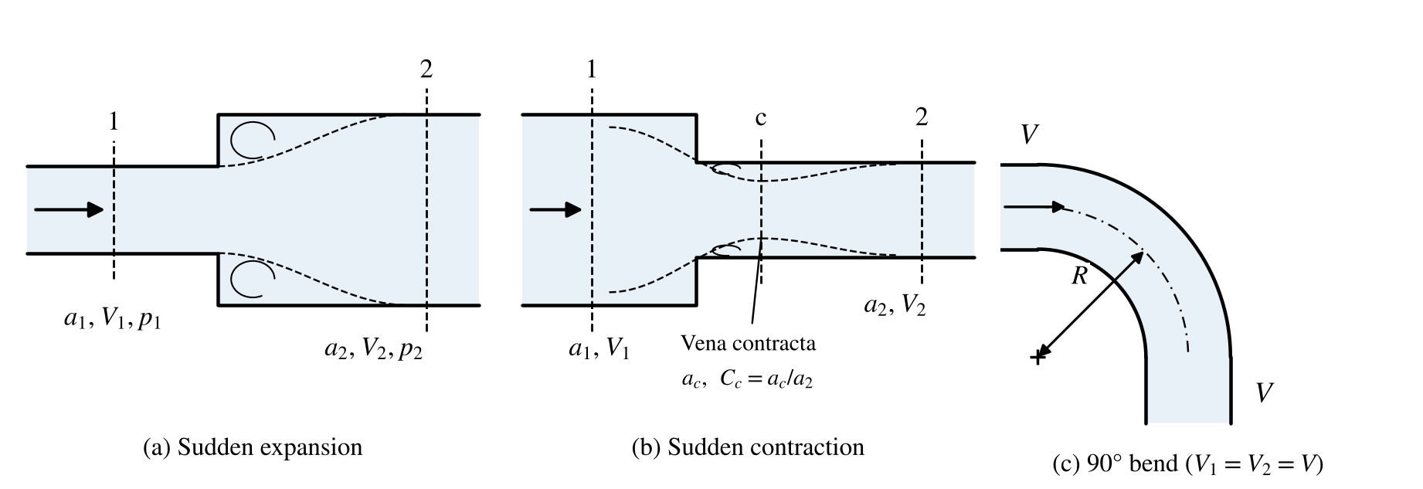
Figure 11: Minor losses – sudden expansion, sudden contraction and bend
With a differential manometer across a fitting, the measured piezometric difference is $\frac{p_{1}-p_{2}}{ρ g}=\frac{12.6 H}{1000}$ (H in mm of Hg). Applying the energy equation between the tappings, the actual loss of head is
$$h_{L}=\frac{p_{1}-p_{2}}{ρ g}+\frac{V_{1}^{2}-V_{2}^{2}}{2g}$$
(For the bend, $V_{1}=V_{2}$ and $h_{L}$ equals the manometer head. For the sudden expansion the downstream pressure is higher, so take the sign of the manometer reading into account.)

9.4 Apparatus
- Pipeline fitted with a sudden expansion, sudden contraction, 90° long bend and 90° elbow, with pressure tappings and ball valves
- Differential (U-tube) mercury manometer
- Centrifugal pump (1 HP, single phase) with control valve, sump tank and measuring tank
- Stopwatch

9.5 Specifications
- Collecting (measuring) tank area, $A$ = 0.12 m²
- Sudden expansion: inlet diameter 16 mm, outlet diameter 27 mm
- Sudden contraction: inlet diameter 27 mm, outlet diameter 16 mm
- Bend: pipe diameter 27 mm

9.6 Experimental Procedure
All the necessary instrumentation and accessories are readily connected. Follow the instructions below:
- Fill the sump tank with clean water.
- Keep the delivery valve closed.
- Connect the power cable to a 1-phase, 220 V, 10 A supply with earth connection.
- Switch ON the pump and open the delivery valve.
- Open the ball valve of the pipe fitting to be tested.
- Adjust the flow through the control valve of the pump.
- Open the corresponding manometer ball valves; expel any air by opening the drain cocks provided on the manometer.
- Note the differential head reading on the manometer.
- Operate the butterfly valve and note the time for a known rise of water level in the collecting tank; keep it open when readings are not being taken.
- Change the flow rate and repeat; then repeat for the other fittings.

9.7 Observations
Table 17: Readings – minor losses
Type of fitting | Valve opening | Rise in water level R (mm) | Time taken t (s) | Manometer reading H (mm of Hg) | Remarks
Sudden expansion | Quarter opening | 100
Sudden expansion | Half opening | 100
Sudden expansion | Full opening | 100
Sudden contraction | Quarter opening | 100
Sudden contraction | Half opening | 100
Sudden contraction | Full opening | 100
90° bend | Quarter opening | 100
90° bend | Half opening | 100
90° bend | Full opening | 100

9.8 Specimen Calculations
1. Actual discharge
$$Q=\frac{A× R}{t}= ......................... m^{3}/s$$
2. Velocities
$$V_{1}=\frac{Q}{a_{1}}= ............... m/s, V_{2}=\frac{Q}{a_{2}}= ............... m/s$$
3. Loss of head across the fitting
$$h_{L}=\frac{12.6 H}{1000}+\frac{V_{1}^{2}-V_{2}^{2}}{2g}= .................... m$$
4. Loss coefficients
$$K_{e}=\frac{h_{L}}{(V_{1}-V_{2})^{2}/2g}, K_{c}=\frac{h_{L}}{V_{2}^{2}/2g}, K_{b}=\frac{h_{L}}{V^{2}/2g}$$
Table 18: Calculations – minor losses
Type of fitting | Valve opening | Discharge Q (m³/s) | V₁ (m/s) | V₂ (m/s) | Loss of head h_{L} (m) | Loss coefficient K
Sudden expansion | Quarter opening
Sudden expansion | Half opening
Sudden expansion | Full opening
Sudden contraction | Quarter opening
Sudden contraction | Half opening
Sudden contraction | Full opening
90° bend | Quarter opening
90° bend | Half opening
90° bend | Full opening

9.9 Precautions
- Do not start the pump if the supply voltage is less than 180 V; ensure correct neutral and earth connections.
- Remove air from the manometer before taking readings.
- Take readings only after the flow has become steady.
- Open the manometer valves gradually to prevent mercury from being blown out.

9.10 Sources of Error
- Parallax error in reading the manometer.
- Fluctuations in the flow rate.
- Error in timing the collection of water.
- Friction loss in the pipe length between the tappings, which is included in the measured loss.

9.11 Applications
Minor loss coefficients are used in the design of water-supply networks, pumping mains, building plumbing and process piping, where many fittings occur over short lengths.

9.12 Result
The head loss in pipes due to different fittings (minor losses) has been determined.
Average loss coefficient: sudden expansion K_{e} = ________________; sudden contraction K_{c} = ________________; bend K_{b} = ________________

9.13 Conclusion
Compare the experimental loss coefficients with the theoretical / handbook values and discuss the reasons for any difference.

Signature of Faculty

Rough Work

Viva Voce Questions
- What are minor losses in pipe flow, and why are they called “minor”?
- Distinguish between major and minor losses.
- Under what conditions can minor losses exceed the friction loss in a pipeline?
- Derive the expression for the loss of head due to sudden enlargement.
- What is the vena contracta, and how does it relate to the loss at a sudden contraction?
- Why is the loss at a sudden contraction smaller than at a sudden enlargement for the same area ratio?
- What is meant by the loss coefficient K of a fitting?
- How does the radius of curvature of a bend affect the head loss?
- What is the difference between a bend and an elbow?
- What is the equivalent length of a pipe fitting?
- Why must the velocity heads be included when calculating the loss across an expansion or contraction from manometer readings?
- Why can the downstream pressure be higher than the upstream pressure across a sudden expansion?
- How is the discharge measured in this experiment?
- Why should air bubbles be removed from the manometer before taking readings?
- What is the loss of head at the entrance to a pipe and at the exit of a pipe?
- How can minor losses be reduced in a pipeline?
- What is the effect of the flow rate on the loss coefficient?
- What are the sources of error in this experiment?
- Why is mercury used as the manometric fluid here?
- How are minor loss coefficients used in pipeline network design?

Date: | Flat and Hemispherical Vanes

10 Determination of Vane Coefficient for Flat and Hemispherical Vanes

10.1 Aim of the Experiment
To determine the force exerted by a jet of water on stationary vanes (flat, hemispherical and inclined), to verify the impulse–momentum equation, and to determine the vane coefficient (coefficient of impact) for each vane.

10.2 Objective
To experimentally determine the vane coefficient (C_{I}) for flat and hemispherical vanes (and an inclined vane) by measuring the force exerted by a jet impinging on each vane.

10.3 Theory
A liquid comes out of a nozzle fitted to a pipe in the form of a jet. Impact of a jet means the force exerted by the jet on a plate or vane, which may be stationary or moving. From the impulse–momentum principle, the force exerted equals the rate of change of momentum of the jet in the direction considered.
Let the jet of velocity $V$ and area $a$ strike a smooth, symmetrical, stationary vane at its centre. If the vane is smooth there is no loss of energy, and the jet leaves the vane with the same velocity $V$, deflected through an angle. The force in the direction of the jet is
$$F=ρ a V (V-Vcosφ)=ρ a V^{2}(1-cosφ)$$
where $φ$ is the angle through which the jet is deflected. For the vanes used here:
- Flat vane (jet deflected through 90°): $F_{th}=ρ a V^{2}$
- Hemispherical vane (jet turned back through 180°): $F_{th}=2ρ a V^{2}$
- Inclined vane (plate inclined at θ = 60°): $F_{th}=ρ a V^{2}sin θ$
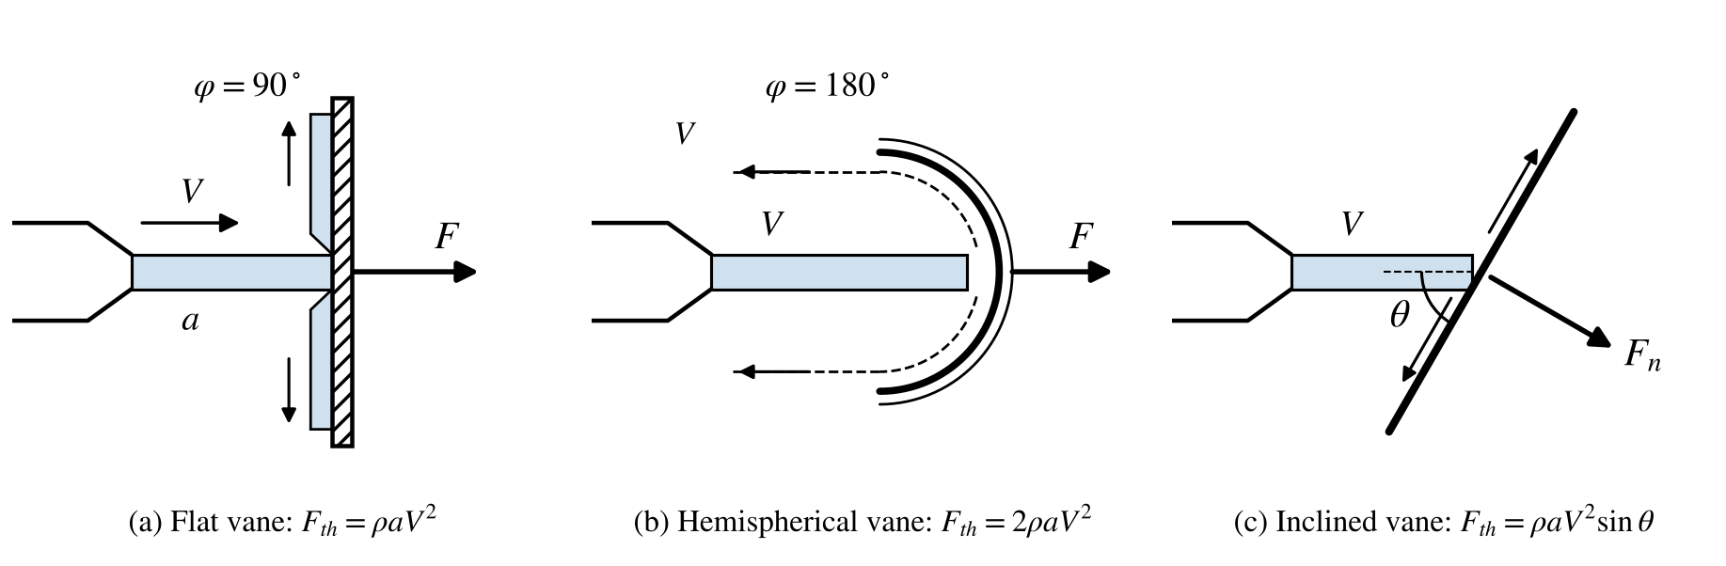
Figure 12: Impact of jet on flat, hemispherical and inclined vanes
The vane coefficient (coefficient of impact) relates the measured and theoretical forces:
$$C_{I}=\frac{F_{act}}{F_{th}}$$

10.4 Apparatus
- Impact-of-jet apparatus with a high-efficiency nozzle fitted to a 25 mm supply line with a gate valve
- Flat, hemispherical and inclined vanes fitted to the vertical bracket of a differential lever that balances the upward force of the jet
- Metric weights placed on the hanger of the lever (balance)
- Rotameter for measuring the flow rate (measuring tank as alternative)
- Stopwatch

10.5 Data
- Diameter of the nozzle, $d$ = 4 mm
- Area of collecting tank (if used), $A$ = 0.09 m²
- Angle of inclined vane, θ = 60°
- Weight of vane assembly = 200 g
- Lever ratio of the load-transfer lever = 60 mm / 30 mm = 2
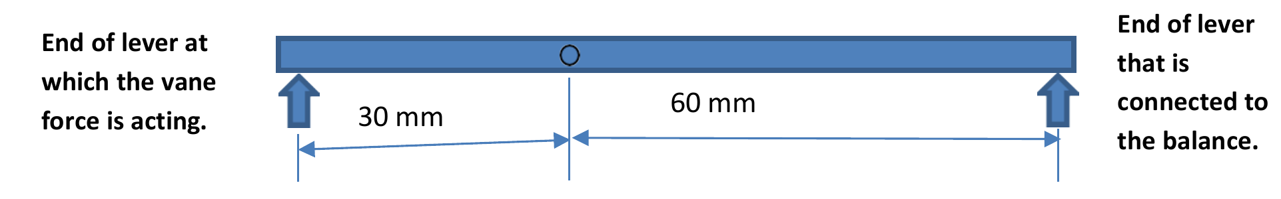
Figure 13: Load-transfer lever of the impact-of-jet apparatus (lever ratio 60 mm / 30 mm = 2) (from the 2025–26 manual)

10.6 Experimental Procedure
- Fix one type of vane to the bracket.
- Ensure that the lever is in the horizontal position (balanced) with no flow.
- Place a known weight on the hanger; the lever will be deflected.
- Open the supply valve and gradually adjust the flow so that the jet brings the lever back to the horizontal position.
- Note the rotameter reading (or the time for a known rise of water in the measuring tank) and the balancing force F_{a}.
- Repeat for different weights, and then for the other vanes.

10.7 Observations
Table 19: Readings – impact of jet
Vane type | Sl. No. | Rotameter reading Q (lpm) | Force on the balance F_{a} (g)
Flat vane | 1
Flat vane | 2
Flat vane | 3
Hemispherical vane | 4
Hemispherical vane | 5
Hemispherical vane | 6
Inclined vane (θ = 60°) | 7
Inclined vane (θ = 60°) | 8
Inclined vane (θ = 60°) | 9

10.8 Specimen Calculations
1. Actual discharge, area of nozzle and jet velocity:
$$Q_{act}=\frac{Q(lpm)}{60×1000} m^{3}/s, a=\frac{π d^{2}}{4} m^{2}, V=\frac{Q_{act}}{a} m/s$$
2. Actual force on the vane:
$$F_{act}=\frac{2× F_{a}×9.81}{1000} N$$
F_{a} is multiplied by 2 to account for the lever-arm effect of the load-transfer lever at the top of the balance: the vane force acts at 30 mm from the fulcrum while the balance is connected at 60 mm.
3. Theoretical force:
$$Flat: F_{th}=ρ aV^{2}; Hemispherical: F_{th}=2ρ aV^{2}; Inclined: F_{th}=ρ aV^{2}sin θ$$
4. Coefficient of impact:
$$C_{I}=\frac{F_{act}}{F_{th}}$$
Table 20: Calculations – impact of jet
Vane type | Sl. No. | Q_{act} (m³/s) | Jet velocity V (m/s) | F_{act} (N) | F_{th} (N) | C_{I}
Flat vane | 1
Flat vane | 2
Flat vane | 3
Hemispherical vane | 4
Hemispherical vane | 5
Hemispherical vane | 6
Inclined vane (θ = 60°) | 7
Inclined vane (θ = 60°) | 8
Inclined vane (θ = 60°) | 9
Comment: The coefficient of impact for the inclined vane may be found to exceed 1. This is because the vane is a double-inclined vane in which the vertical velocity of water is brought to zero at the joint between its two inclined planes, so the simple single-plate formula underestimates the force.

10.9 Graphs
- Plot $F_{act}$ versus $ρ aV^{2}$ for each vane; the slope gives the average $C_{I}$.

10.10 Precautions
- Ensure the vanes are correctly positioned to receive the full impact of the jet.
- Check that the lever is exactly horizontal before each reading.
- Allow the flow to become steady before taking measurements.
- Remove air bubbles from the rotameter to ensure accurate readings.

10.11 Sources of Error
- Parallax error in reading the rotameter.
- Fluctuations in jet flow rate affecting force measurement.
- Friction at the lever pivot.

10.12 Applications
Vane coefficients are useful in understanding impact forces in turbine blades (e.g., Pelton buckets), flow meters and various hydraulic structures where fluid jets interact with different surfaces.

10.13 Result
The coefficients of impact for flat, hemispherical and inclined vanes have been determined.
Flat vane C_{I} = ________________; hemispherical vane C_{I} = ________________; inclined vane C_{I} = ________________

10.14 Conclusion
Discuss the relationship between vane shape and the force exerted by the jet. Compare the results for the flat and hemispherical vanes and discuss any differences in C_{I}.

Signature of Faculty

Rough Work

Viva Voce Questions
- What is a vane, and where are vanes commonly used?
- What is the purpose of determining the vane coefficient?
- What is the difference between a flat vane and a hemispherical vane?
- How does the shape of a vane affect the force exerted by a fluid?
- What is the vane coefficient, and how is it defined?
- Why is the vane coefficient important in hydraulic machines?
- What is the theoretical force exerted on a flat vane by a jet of water?
- How is the actual force on a flat vane measured in the experiment?
- How is the theoretical force exerted on a hemispherical vane different from that on a flat vane?
- How do you calculate the actual force exerted on a hemispherical vane?
- What is the formula for determining the vane coefficient?
- What factors affect the vane coefficient for flat and hemispherical vanes?
- Why might the vane coefficient be less than 1?
- How does the angle of impact affect the force on a flat vane?
- What are the units of the vane coefficient?
- What equipment is used to measure the force on the vane?
- How do you ensure accurate measurement of force in this experiment?
- What is the purpose of the deflection angle in vane force analysis?
- How does the velocity of the jet impact the force on the vane?
- What precautions should be taken to avoid errors in this experiment?
- Why is it necessary to conduct tests on both flat and hemispherical vanes?
- How does a hemispherical vane direct the flow of fluid compared to a flat vane?
- How do you calculate the force exerted by a fluid jet on a moving vane?
- What assumptions are made in the theoretical calculation of force on a vane?
- Why might there be a discrepancy between theoretical and actual force values?
- What is the significance of the deflection angle for hemispherical vanes?
- How does friction affect the vane coefficient?
- What would happen to the force if the vane surface were not smooth?
- What applications utilize flat vanes and hemispherical vanes in fluid machinery?
- How would you determine the vane coefficient for an angled or curved vane?

Date: | Single-Stage Centrifugal Pump

11 Performance Tests on a Single-Stage Centrifugal Pump

11.1 Aim of the Experiment
To conduct performance tests on a single-stage centrifugal pump and to obtain its main and operating characteristics.

11.2 Objective
To evaluate the performance of a single-stage centrifugal pump by measuring discharge, head, input power and efficiency under varying speed and flow conditions.

11.3 Theory
A centrifugal pump converts the mechanical energy supplied by a motor into the kinetic and pressure energy of a liquid. Water enters the eye (centre) of the rotating impeller and is subjected to radial acceleration by the impeller blades; the kinetic energy is then converted into pressure energy in the volute casing. Centrifugal pumps are widely used for water supply, irrigation and in industry.
- Total head (H): the head developed by the pump – the sum of the delivery pressure head and the suction (vacuum) head.
- Input power (IP): the power supplied to the pump shaft by the motor.
- Output power (BP): the power imparted to the water, $ρ gQH$.
- Efficiency (η): $η=\frac{ρ gQH}{IP}×100\%$
Main characteristics are curves of H, IP and η against Q at different constant speeds. Operating characteristics are the curves of H, IP, BP and η against Q at the rated (constant) speed.

11.4 Specifications
Item | Specification
Electrical supply | 230 V, 15 A, AC, single phase, 50 Hz with neutral and earth connections
Motor | AC motor, 1.5 HP, 1500 rpm
Pump | Kirloskar centrifugal pump, maximum speed 2880 rpm
Pressure gauge | 0–2 kg/cm²
Vacuum gauge | 0–760 mm of Hg
Energy meter constant | 1200 rev/kWh
Speed indicator | 0–9999 rpm (digital)
Control valves | For suction and delivery
Measuring tank base area | 0.25 m²

11.5 Experimental Procedure
The pump can be run at three different speeds by shifting the V-belt between the three grooves of the pulleys. After changing the belt position, adjust the belt tension using the belt-tensioning mechanism.

A. To obtain main characteristics
This test is carried out by running the pump at different speeds and different discharges. Different discharges are obtained by adjusting the delivery valve.
- Keep the delivery gate valve of the pump closed.
- Switch on the pump.
- Open the delivery valve slightly so that the delivery pressure is readable.
- Close the butterfly valve of the collecting tank and note the time t_{w} for a 100 mm rise of water level. Note the pump speed (rpm).
- Note the delivery pressure gauge reading, the suction vacuum gauge reading and the time T for 20 revolutions of the energy-meter disc.
- Open the delivery valve further to increase the discharge and repeat steps 4–5.
- Repeat for at least five discharges at the given speed.
- Change the pump speed by shifting the V-belt to the adjacent groove and repeat steps 4–7 for all available speeds.

B. To obtain operating characteristics
These are obtained by running the pump at a constant speed and different discharges. A separate test is not needed: the readings taken for the main characteristics at the pump speed of 2475 rpm are used.

11.6 Formulae
1. Total head (m of water):
$$H=10 H_{d}+\frac{13.6 H_{v}}{1000}$$
where $H_{d}$ = delivery pressure (kg/cm²) and $H_{v}$ = suction vacuum (mm of Hg). (Add the vertical distance between the gauge points, if significant.)
2. Discharge:
$$Q=\frac{A× h}{t_{w}} m^{3}/s$$
where $A$ = 0.25 m², $h$ = 0.1 m (rise of water) and $t_{w}$ = time for 100 mm rise (s).
3. Input power to the pump:
$$IP=\frac{20}{T}×\frac{3600}{1200}×0.75 kW$$
where $T$ = time for 20 revolutions of the energy-meter disc (s), 1200 = energy-meter constant (rev/kWh) and 0.75 = combined efficiency of motor and belt transmission.
4. Output power of the pump:
$$BP=\frac{ρ g Q H}{1000} kW$$
5. Efficiency:
$$η=\frac{BP}{IP}×100 \%$$

11.7 Observations
Table 21: Test readings for main characteristics of the centrifugal pump
Reading set | Speed (rpm) | Trial No. | Suction head H_{v} (mm of Hg) | Delivery head H_{d} (kg/cm²) | Time t_{w} for 100 mm rise (s) | Time T for 20 rev. of energy meter (s)
A | 2275 | 1
A | 2275 | 2
A | 2275 | 3
A | 2275 | 4
A | 2275 | 5
B | 2475 | 1
B | 2475 | 2
B | 2475 | 3
B | 2475 | 4
B | 2475 | 5
C | 2575 | 1
C | 2575 | 2
C | 2575 | 3
C | 2575 | 4
C | 2575 | 5
Table 22: Results for main characteristics of the centrifugal pump
Reading set | Speed (rpm) | Trial No. | Discharge Q (m³/s) | Total head H (m) | Input power IP (kW) | Output power BP (kW) | Efficiency η (%)
A | 2275 | 1
A | 2275 | 2
A | 2275 | 3
A | 2275 | 4
A | 2275 | 5
B | 2475 | 1
B | 2475 | 2
B | 2475 | 3
B | 2475 | 4
B | 2475 | 5
C | 2575 | 1
C | 2575 | 2
C | 2575 | 3
C | 2575 | 4
C | 2575 | 5

11.8 Graphs
- Main characteristics: H vs Q, IP vs Q and η vs Q for each speed (on common axes).
- Operating characteristics (2475 rpm): Q on the x-axis; H, IP, BP and η on the y-axis.

11.9 Precautions
- Prime the pump and never run it dry.
- Start the pump with the delivery valve closed.
- Ensure there are no air bubbles in the suction line.
- Allow the pump to reach steady state before recording measurements.
- Check the belt tension after shifting the belt.

11.10 Sources of Error
- Parallax error in reading gauges.
- Fluctuations in the flow rate affecting measurements.
- Error in timing the energy-meter revolutions.

11.11 Applications
Single-stage centrifugal pumps are widely used in water supply, irrigation and drainage systems, as well as in various industrial processes.

11.12 Result
The main and operating characteristics of the centrifugal pump have been obtained.
Maximum efficiency at 2475 rpm = ________________ %, at a discharge of ________________ m³/s and head of ________________ m.

11.13 Conclusion
Discuss the impact of varying flow rate and speed on the efficiency and head developed by the pump, and how this relates to typical pump performance curves.

Signature of Faculty

Rough Work

Viva Voce Questions
- What is a centrifugal pump, and where is it used?
- How does a centrifugal pump operate?
- What is meant by a single-stage centrifugal pump?
- What are the main components of a centrifugal pump?
- What is the function of the impeller in a centrifugal pump?
- Explain the role of the volute casing in a centrifugal pump.
- What is the purpose of conducting performance tests on a centrifugal pump?
- How is the flow rate of water measured in this experiment?
- What equipment is used to measure the pump’s speed?
- How do you calculate the net head developed by the centrifugal pump?
- What is the formula for hydraulic efficiency in a centrifugal pump?
- How is overall efficiency different from hydraulic efficiency?
- What is the purpose of a performance curve for a centrifugal pump?
- What is meant by the term "shutoff head" in centrifugal pumps?
- How do you measure the input power of a centrifugal pump?
- What is meant by "priming" in centrifugal pumps, and why is it necessary?
- How does the impeller diameter affect the performance of the pump?
- How is the specific speed of a centrifugal pump calculated?
- What factors affect the efficiency of a centrifugal pump?
- Why is it important to maintain a steady suction head during testing?
- What could be the consequences of cavitation in a centrifugal pump?
- How would you identify cavitation during the performance test?
- How does the flow rate affect the head developed by the pump?
- What happens to the efficiency of the pump at low and high flow rates?
- What are some common sources of error in the centrifugal pump experiment?
- How would you calculate the power output of the pump?
- How does the pump head vary with changes in impeller speed?
- What is the purpose of throttling in the discharge valve of the pump?
- What is meant by the "duty point" of a centrifugal pump?
- How would you determine if the pump is operating at its best efficiency point?

Date: | Pelton Wheel Turbine

12 Performance Tests on a Pelton Wheel Turbine

12.1 Aim of the Experiment
To conduct performance tests on a Pelton wheel turbine and to obtain its main and operating characteristics.

12.2 Objective
To evaluate the performance of a Pelton wheel turbine by determining its power output, efficiency and behaviour under different loads and speeds.

12.3 Theory
A Pelton wheel is an impulse turbine used for high-head, low-flow applications. The entire available head is converted into kinetic energy in the nozzle, and the high-velocity jet strikes spoon-shaped (double-cup) buckets attached to the periphery of the wheel, which rotates and generates mechanical energy. The quantity of water is controlled by the spear (needle) valve.
- Hydraulic (input) power: $P_{h}=ρ g Q H$
- Brake (shaft) power: $P_{m}=T ω=\frac{2π NT}{60}$, where $T$ = torque (N·m) and $N$ = speed (rpm)
- Overall efficiency: $η=\frac{P_{m}}{P_{h}}×100\%$

12.4 Specifications
Item | Specification
High-head supply pump motor | 7.5 hp, 3 phase, 440 V, 50 Hz AC
Mean diameter of runner | 250 mm
Number of buckets | 20
Water-jet diameter | 18 mm
Runaway speed | 2000 rpm
Maximum flow rate | 250 litres per minute
Maximum head | 75 m
Maximum shaft output | 1.5 hp
Loading | Brake drum; effective radius (drum radius + rope diameter) R = 0.135 m
Discharge measurement | V-notch, θ = 90°, C_{d} = 0.6

12.5 Experimental Procedure
The centrifugal pump supplies water at high head to the Pelton turbine; its discharge is controlled by the delivery valve. The quantity of water supplied to the turbine is controlled by the spear valve. The turbine discharge is measured using the V-notch and the turbine is loaded using the brake drum.

A. To obtain main characteristics (variable speed)
This test is carried out by running the turbine at different loads; the turbine speed is not held constant.
- Note the V-notch upstream water level H₁ (still-water level at the sill) before starting.
- Keep the pump delivery gate valve closed and the spear valve at the minimum position.
- Release the ropes over the brake drum using the hand wheel so that the turbine is on no load.
- Switch on the pump and open the gate valve.
- Adjust the spear valve so that the turbine speed is about 1950 rpm.
- Note the inlet pressure-gauge reading, the V-notch upstream water level H₂, the turbine speed and the brake-drum spring-balance readings F₁ and F₂.
- Tighten the brake using the hand wheel so that the spring balance reads 1.0 kg (the speed will drop) and repeat the readings of step 6.
- Repeat step 7 for spring-balance readings of 2.0, 3.0, 4.0 and 5.0 kg.

B. To obtain operating characteristics (constant speed)
- Note the V-notch upstream water level H₁. Keep the pump delivery valve closed, the spear valve at minimum and the brake drum on no load.
- Switch on the pump and open the delivery gate valve fully.
- Operate the spear valve so that the turbine speed is 1250 rpm.
- Note the head on the turbine, V-notch water level, turbine speed and spring-balance readings.
- Load the brake drum so that the spring balance reads 1.5 kg; the speed will drop. Adjust the spear valve to bring the speed back to 1250 rpm and note the readings.
- Repeat step 5 for loads of 3.0, 4.5 and 6.0 kg, each time restoring the speed to 1250 rpm.
- Release the load gradually, adjusting the spear valve so that the speed does not exceed 2000 rpm.
- Repeat steps 3–7 at turbine speeds of 1500 rpm and 1750 rpm.

12.6 Formulae
1. Net head on turbine: $H=10× P$ m of water, where $P$ = pressure-gauge reading (kg/cm²).
2. Head over the V-notch: $h=\frac{H_{2}-H_{1}}{1000}$ m
3. Discharge through the turbine (V-notch):
$$Q=\frac{8}{15}C_{d}\sqrt{2g}tan\left(\frac{θ}{2}\right)h^{5/2} m^{3}/s, C_{d}=0.6, θ=90°$$
4. Hydraulic power input:
$$P_{h}=\frac{ρ g Q H}{1000} kW$$
5. Brake power of the turbine: torque $T=(F_{1}-F_{2})×9.81× R$ N·m, with $R$ = 0.135 m
$$P_{m}=\frac{2π NT}{60×1000} kW$$
6. Turbine efficiency:
$$η_{t}=\frac{P_{m}}{P_{h}}×100 \%$$
7. Unit quantities (under unit head):
$$N_{u}=\frac{N}{\sqrt{H}}, P_{u}=\frac{P}{H^{3/2}}, Q_{u}=\frac{Q}{\sqrt{H}}$$
8. Specific speed:
$$N_{s}=\frac{N\sqrt{P}}{H^{5/4}}$$
For calculating specific speed, the power P is taken in kW and N, H, P correspond to the point of maximum efficiency.

12.7 Observations
V-notch upstream water level before the start of the experiment, H₁ = ________________ mm
Table 23: Test readings for main characteristics of the Pelton turbine
Trial No. | Speed N (rpm) | Brake drum reading |  | V-notch upstream water level H₂ (mm) | Inlet pressure P (kg/cm²)
Trial No. | Speed N (rpm) | F₁ (kg) | F₂ (kg) | V-notch upstream water level H₂ (mm) | Inlet pressure P (kg/cm²)
1 |  | 0 | 0
2 |  | 1.0
3 |  | 2.0
4 |  | 3.0
5 |  | 4.0
6 |  | 5.0
Table 24: Results for main characteristics of the Pelton turbine
Trial No. | Speed N (rpm) | Net head H (m) | Discharge Q (m³/s) | Hydraulic power P_{h} (kW) | Brake power P_{m} (kW) | Efficiency η_{t} (%)
1 |  |  |  |  | 0 | 0
2
3
4
5
6
V-notch upstream water level before the start of the experiment, H₁ = ________________ mm
Table 25: Test readings for operating characteristics of the Pelton turbine
Speed N (rpm) | Trial No. | Brake drum reading |  | V-notch upstream water level H₂ (mm) | Inlet pressure P (kg/cm²)
Speed N (rpm) | Trial No. | F₁ (kg) | F₂ (kg) | V-notch upstream water level H₂ (mm) | Inlet pressure P (kg/cm²)
1250 | 1 | 0 | 0
1250 | 2 | 1.5
1250 | 3 | 3.0
1250 | 4 | 4.5
1250 | 5 | 6.0
1500 | 6 | 0 | 0
1500 | 7 | 1.5
1500 | 8 | 3.0
1500 | 9 | 4.5
1500 | 10 | 6.0
1750 | 11 | 0 | 0
1750 | 12 | 1.5
1750 | 13 | 3.0
1750 | 14 | 4.5
1750 | 15 | 6.0
Table 26: Results for operating characteristics of the Pelton turbine
Speed N (rpm) | Trial No. | Net head H (m) | Discharge Q (m³/s) | Hydraulic power P_{h} (kW) | Brake power P_{m} (kW) | Efficiency η_{t} (%)
1250 | 1 |  |  |  | 0 | 0
1250 | 2
1250 | 3
1250 | 4
1250 | 5
1500 | 6 |  |  |  | 0 | 0
1500 | 7
1500 | 8
1500 | 9
1500 | 10
1750 | 11 |  |  |  | 0 | 0
1750 | 12
1750 | 13
1750 | 14
1750 | 15

12.8 Graphs
- Main characteristics: P_{m}, η_{t} and Q versus N (or N_{u}).
- Operating characteristics: η_{t} versus P_{m} (or % full load) at each constant speed.

12.9 Precautions
- Ensure no air is present in the water supply line.
- Apply and release the brake load gradually; avoid excessive loads.
- Never allow the turbine speed to exceed the runaway speed of 2000 rpm.
- Allow the turbine to reach steady state before taking measurements.
- Keep the brake drum cooled with water if it heats up.

12.10 Sources of Error
- Inaccuracies in pressure-gauge or V-notch readings.
- Parallax error in reading the spring balances.
- Fluctuations in the water flow affecting measurements.

12.11 Applications
Pelton wheel turbines are widely used in hydroelectric power plants, particularly where high-head, low-flow water sources are available.

12.12 Result
The main and operating characteristics of the Pelton wheel turbine have been obtained.
Maximum efficiency = ________________ %; specific speed N_{s} = ________________

12.13 Conclusion
Discuss how changes in load and flow rate affect the turbine’s efficiency, and how the turbine behaves at optimal operating conditions.

Signature of Faculty

Rough Work

Viva Voce Questions
- What is a Pelton wheel turbine, and where is it used?
- How does a Pelton wheel differ from Kaplan and Francis turbines?
- What type of head (low, medium, or high) is suitable for a Pelton turbine?
- How does a Pelton wheel operate?
- What are the main components of a Pelton wheel turbine?
- Why is the Pelton wheel considered an impulse turbine?
- What is the purpose of buckets in a Pelton wheel turbine?
- How does the design of the bucket affect the performance of a Pelton wheel?
- Explain the function of the nozzle in a Pelton wheel turbine.
- What is the role of the deflector in a Pelton wheel turbine?
- What is the purpose of conducting performance tests on a Pelton wheel turbine?
- How do you measure the flow rate of water in a Pelton wheel experiment?
- What equipment is used to measure the speed of the Pelton wheel turbine?
- How is the net head calculated in a Pelton wheel turbine setup?
- What measurements are necessary to calculate hydraulic efficiency in the Pelton wheel turbine?
- How is hydraulic efficiency different from mechanical efficiency in this context?
- What is the formula for hydraulic efficiency in a Pelton wheel turbine?
- How would you determine the overall efficiency of a Pelton wheel turbine?
- What factors influence the efficiency of a Pelton wheel turbine?
- Why is it important to maintain a steady head during testing of the Pelton wheel?
- What are the effects of changing the jet velocity on the Pelton wheel’s output?
- Why is it necessary to avoid splash or spray during the performance test?
- What could be the consequences of cavitation in a Pelton wheel turbine?
- How would you identify cavitation in the Pelton turbine during the experiment?
- What is the purpose of plotting the performance curve for the Pelton wheel turbine?
- Why might there be differences between theoretical and observed efficiencies?
- How does the speed ratio affect the performance of the Pelton wheel?
- What are some common sources of error in the Pelton wheel turbine experiment?
- What is meant by the term "specific speed" for a Pelton wheel turbine?
- How do impulse turbines like the Pelton wheel differ in energy conversion compared to reaction turbines?

Date: | Francis Turbine

13 Performance Tests on a Francis Turbine

13.1 Aim of the Experiment
To conduct performance tests on a Francis turbine and to obtain its operating (constant-speed) and main (constant-head) characteristics.

13.2 Objective
To assess the performance of a Francis turbine by determining its efficiency, power output and characteristics under various load conditions.

13.3 Theory
A Francis turbine is a mixed-flow reaction turbine commonly used in medium-head hydroelectric installations. Water enters the runner radially through adjustable guide vanes and leaves axially through the draft tube; both the kinetic and pressure energy of the water are converted into mechanical energy. The draft tube recovers part of the exit kinetic energy, so the head on the turbine includes the suction (vacuum) head at the exit.
- Hydraulic (input) power: $P_{h}=ρ g Q H$
- Output power: measured electrically from the alternator through the energy meter
- Efficiency: $η=\frac{P_{out}}{P_{h}}×100\%$

13.4 Specifications
- Turbine: 150 mm diameter runner; maximum flow ≈ 1200 lpm; maximum head ≈ 20 m
- Loading: AC alternator with bulb (lamp) load bank
- Flow measurement: venturimeter, inlet diameter D = 100 mm, throat diameter d = 60 mm, C_{d} = 0.9
- Supply water control by butterfly (gate) valve
- Energy-meter constant, K = ________________ rev/kWh

13.5 Experimental Procedure

A. To obtain constant-speed characteristics (operating characteristics)
- Keep the gate partially open and set the guide-vane opening so that the turbine speed is 1300 rpm.
- For different electrical loads on the generator, change the gate opening so that the speed is held constant. Ensure that the voltage does not exceed 250 V to protect the bulbs.
- Note the pressure and vacuum gauge readings, venturimeter inlet and throat pressures, voltage, current and the time for 5 revolutions of the energy-meter disc.
- Change the guide-vane setting and repeat step 2 for speeds of 1200 rpm and 1100 rpm.

B. To obtain constant-head characteristics (main characteristics)
- Select the guide-vane position.
- Keep the gate closed and start the pump.
- Slowly open the gate and set the pressure on the gauge (head).
- For different electrical loads, adjust the gate-valve position to maintain the constant head and note all readings.
- Repeat for the other guide-vane positions.

13.6 Formulae
1. Net head on the turbine:
$$H=10 P+\frac{13.6 P_{v}}{1000} m of water$$
where $P$ = pressure-gauge reading (kg/cm²) and $P_{v}$ = vacuum-gauge reading (mm of Hg).
2. Discharge through the turbine (venturimeter):
$$Q=C_{d}\frac{a_{1}a_{2}\sqrt{2gh}}{\sqrt{a_{1}^{2}-a_{2}^{2}}} m^{3}/s$$
where $C_{d}$ = 0.9, $a_{1}=\frac{π(0.1)^{2}}{4}$ m², $a_{2}=\frac{π(0.06)^{2}}{4}$ m², and $h=10(P_{i}-P_{t})$ m of water (1 kg/cm² ≈ 10 m of water).
3. Input (water) power to the turbine:
$$IP=\frac{ρ g Q H}{1000} kW$$
4. Output (shaft) power of the turbine:
$$BP=\frac{5×3600}{K× t×0.75} kW$$
where $t$ = time for 5 revolutions of the energy-meter disc (s), $K$ = energy-meter constant (rev/kWh) and 0.75 = efficiency of the alternator.
5. Turbine efficiency:
$$η_{t}=\frac{BP}{IP}×100 \%$$
6. Unit quantities and specific speed: $N_{u}=\frac{N}{\sqrt{H}}$, $P_{u}=\frac{P}{H^{3/2}}$, $Q_{u}=\frac{Q}{\sqrt{H}}$, $N_{s}=\frac{N\sqrt{P}}{H^{5/4}}$ (P in kW, at maximum efficiency).

13.7 Observations
Table 27: Readings – constant-speed (operating) characteristics
Method: keeping the guide-vane opening constant and changing the gate-valve position.
Speed N (rpm) | Head on turbine |  | Venturimeter |  | P_{i} − P_{t} (kg/cm²) | Load on generator |  | Time t for 5 rev. of energy meter (s)
Speed N (rpm) | Pressure P (kg/cm²) | Vacuum P_{v} (mm of Hg) | Inlet P_{i} (kg/cm²) | Throat P_{t} (kg/cm²) | P_{i} − P_{t} (kg/cm²) | V (volts) | I (amps) | Time t for 5 rev. of energy meter (s)
1300
1200
1100
Table 28: Readings – constant-head (main) characteristics
Method: keeping the guide-vane angle constant and changing the gate-valve position.
Guide vane position | Speed N (rpm) | Head on turbine |  | Venturimeter |  | P_{i} − P_{t} (kg/cm²) | Load on generator |  | Time t for 5 rev. of energy meter (s)
Guide vane position | Speed N (rpm) | Pressure P (kg/cm²) | Vacuum P_{v} (mm of Hg) | Inlet P_{i} (kg/cm²) | Throat P_{t} (kg/cm²) | P_{i} − P_{t} (kg/cm²) | V (volts) | I (amps) | Time t for 5 rev. of energy meter (s)
Position 1
Position 2
Position 3
Table 29: Calculations – constant-speed characteristics
Speed N (rpm) | Net head H (m) | Discharge Q (m³/s) | Input power IP (kW) | Output power BP (kW) | Efficiency η_{t} (%)
1300
1200
1100
Table 30: Calculations – constant-head characteristics
Guide vane position | Net head H (m) | Discharge Q (m³/s) | Input power IP (kW) | Output power BP (kW) | Efficiency η_{t} (%) | Speed N (rpm)
Position 1
Position 2
Position 3

13.8 Graphs
- Operating characteristics: η_{t} and Q versus BP (or % full load) at each constant speed.
- Main characteristics: BP, η_{t} and Q versus N (or N_{u}) at constant head.

13.9 Precautions
- Ensure that the system is free of air bubbles before starting the experiment.
- Adjust the load gradually to prevent sudden fluctuations that may damage the turbine.
- Do not allow the alternator voltage to exceed 250 V.
- Allow steady-state conditions to establish before recording measurements.

13.10 Sources of Error
- Inaccurate calibration of pressure and flow measurement devices.
- Parallax error in reading gauge measurements.
- Variations in water flow due to unstable pressure.

13.11 Applications
Francis turbines are commonly used in hydroelectric power plants, especially where medium-head water sources are available.

13.12 Result
The operating and main characteristics of the Francis turbine have been obtained.
Maximum efficiency = ________________ %; specific speed N_{s} = ________________

13.13 Conclusion
Discuss the effect of load and flow conditions on the turbine’s efficiency and how well the results align with expected performance.

Signature of Faculty

Rough Work

Viva Voce Questions
- What is a Francis turbine, and where is it used?
- How does a Francis turbine differ from a Kaplan turbine?
- What type of flow (axial, radial, or mixed) does a Francis turbine use?
- Why is the Francis turbine suitable for medium-head applications?
- What are the main components of a Francis turbine?
- How does the Francis turbine operate?
- What is the purpose of guide vanes in a Francis turbine?
- Explain the function of the runner in the Francis turbine.
- What is the purpose of a draft tube in a Francis turbine setup?
- How does the design of the runner blades affect turbine performance?
- What is the purpose of conducting performance tests on a Francis turbine?
- How do you measure the flow rate of water in the Francis turbine experiment?
- What equipment is used to measure the turbine’s speed?
- How do you calculate the net head in a Francis turbine setup?
- What measurements are necessary to calculate the hydraulic efficiency of the Francis turbine?
- How is hydraulic efficiency different from mechanical efficiency?
- What is the formula for calculating hydraulic efficiency in a Francis turbine?
- How would you determine the mechanical efficiency of the Francis turbine?
- How would you calculate the overall efficiency of a Francis turbine?
- What factors can affect the efficiency of a Francis turbine?
- What are the typical applications of a Francis turbine in power generation?
- Why is it important to ensure proper alignment of the water flow with the turbine axis?
- What could be the consequences of cavitation in a Francis turbine?
- How would you detect cavitation during the experiment?
- Why is it essential to maintain a steady head during performance tests?
- How does varying the water flow rate impact the output power of the turbine?
- What are the effects of adjusting the guide vane angle on turbine performance?
- What is the purpose of plotting the performance curve of a Francis turbine?
- Why might there be a difference between the theoretical and actual efficiencies observed?
- What are some common sources of error in the Francis turbine experiment?

Date: | Kaplan Turbine

14 Performance Tests on a Kaplan Turbine

14.1 Aim of the Experiment
To study the performance of a Kaplan turbine and to draw its operating characteristics at constant speed and main characteristics at constant head.

14.2 Objective
To conduct performance tests on a Kaplan turbine and evaluate its efficiency, power output and operational characteristics under various load conditions.

14.3 Theory
A Kaplan turbine is an axial-flow reaction turbine with adjustable runner blades, designed for low-head, high-flow conditions. Because both the guide vanes and the runner blades can be adjusted, the Kaplan turbine maintains a high efficiency over a wide range of loads. It is commonly used in hydroelectric plants on rivers and in tidal power stations.
- Hydraulic (input) power: $P_{h}=ρ g Q H$
- Output power: measured electrically from the alternator through the energy meter
- Efficiency: $η=\frac{P_{out}}{P_{h}}×100\%$

14.4 Specifications
- Maximum rated power: 4 kW
- Runner (impeller) diameter: 150 mm
- Maximum allowable (runaway) speed: 3000 rpm
- Discharge measurement: rectangular notch, breadth b = 250 mm, C_{d} = 0.6
- Loading: electrical (alternator with switched load bank); energy-meter constant K = ________________ rev/kWh

14.5 Experimental Procedure

General operating procedure
- Keep the pump delivery gate valve closed and the rotor-blade opening valve at the minimum position (using the hand wheel).
- Switch on the centrifugal pump.
- Set the pump delivery gate valve to the maximum opening position.
- Open the rotor-blade opening valve slightly using the hand wheel; the turbine will start to rotate. Watch the alternator voltmeter and ensure the voltage does not exceed 250 V by limiting the turbine speed.
- Depending on the load, adjust the rotor-blade opening valve to obtain the required speed.

A. Constant-speed characteristics (operating characteristics)
- Follow steps 1–4 of the general procedure.
- With the turbine on no load, open the rotor-blade valve so that the speed is 1500 rpm (select a lower speed if the voltage exceeds 250 V). Note the speed, inlet pressure P, outlet vacuum P_{v}, time t for 4 revolutions of the energy meter, head over notch h, voltmeter and ammeter readings and the number of engaged switches.
- Engage 2 switches; the speed will drop. Increase the rotor-blade opening to restore 1500 rpm, wait about 5 minutes for the flow to stabilise, and note the readings.
- Engage 2 more switches, restore the speed, and note the readings. Continue until all switches are engaged.
- Close the rotor-blade valve, disengage all switches and bring the turbine to no load.
- Repeat the test at 1300 rpm and at 1000 rpm, returning the turbine to no load after each test.
Table 31: Readings – constant-speed (operating) characteristics
Speed N (rpm) | No. of engaged switches | Head on turbine |  | Energy meter |  | Voltmeter V (volts) | Ammeter I (amps) | Head over notch h (mm)
Speed N (rpm) | No. of engaged switches | P (kg/cm²) | P_{v} (mm of Hg) | Rev. n | Time t (s) | Voltmeter V (volts) | Ammeter I (amps) | Head over notch h (mm)
1500 | 0 |  |  | 4
1500 | 2 |  |  | 4
1500 | 4 |  |  | 4
1500 | 6 |  |  | 4
1500 | 8 |  |  | 4
1500 | 10 |  |  | 4
1300 | 0 |  |  | 4
1300 | 2 |  |  | 4
1300 | 4 |  |  | 4
1300 | 6 |  |  | 4
1300 | 8 |  |  | 4
1300 | 10 |  |  | 4
1000 | 0 |  |  | 4
1000 | 2 |  |  | 4
1000 | 4 |  |  | 4
1000 | 6 |  |  | 4
1000 | 8 |  |  | 4
1000 | 10 |  |  | 4
Table 32: Calculations – constant-speed characteristics
Speed N (rpm) | Net head H (m) | Discharge Q (m³/s) | Input power IP (kW) | Output power BP (kW) | Efficiency η_{t} (%) | % of full load
1500
1300
1000

B. Constant-head characteristics (main characteristics)
- Follow steps 1 and 2 of the general procedure.
- Set the pump delivery gate valve to ¼ opening. Open the rotor-blade valve until the alternator voltage is about 250 V and note the speed N₁ together with all other readings.
- Engage 2 switches; the turbine is loaded and its speed drops. Note the readings. If the turbine inlet pressure drops, adjust the gate valve to maintain it.
- Engage 2 more switches and note the readings; continue until all switches are engaged. Then close the rotor-blade valve and disengage all switches.
- Set the delivery valve at ½ opening and open the rotor-blade valve so that the speed is 150 rpm less than N₁ (call it N₂). Repeat steps 3–4.
- Set the delivery valve at ¾ opening with speed N₃ = N₂ − 150 rpm and repeat; then at full opening with speed N₃ − 150 rpm and repeat.
Table 33: Readings – constant-head (main) characteristics
Head on turbine |  | Speed N (rpm) | No. of engaged switches | Energy meter |  | Voltmeter V (volts) | Ammeter I (amps) | Head over notch h (mm)
P (kg/cm²) | P_{v} (mm of Hg) | Speed N (rpm) | No. of engaged switches | Rev. n | Time t (s) | Voltmeter V (volts) | Ammeter I (amps) | Head over notch h (mm)
 |  |  | 0 | 4
 |  |  | 2 | 4
 |  |  | 4 | 4
 |  |  | 6 | 4
 |  |  | 8 | 4
 |  |  | 10 | 4
 |  |  | 0 | 4
 |  |  | 2 | 4
 |  |  | 4 | 4
 |  |  | 6 | 4
 |  |  | 8 | 4
 |  |  | 10 | 4
 |  |  | 0 | 4
 |  |  | 2 | 4
 |  |  | 4 | 4
 |  |  | 6 | 4
 |  |  | 8 | 4
 |  |  | 10 | 4
 |  |  | 0 | 4
 |  |  | 2 | 4
 |  |  | 4 | 4
 |  |  | 6 | 4
 |  |  | 8 | 4
 |  |  | 10 | 4
Table 34: Calculations – constant-head characteristics
Net head H (m) | Speed N (rpm) | Discharge Q (m³/s) | Input power IP (kW) | Output power BP (kW) | Efficiency η_{t} (%) | % of full load

14.6 Formulae
1. Output power of the turbine:
$$BP=\frac{n×3600}{K× t×0.75} kW$$
where $n$ = number of revolutions of the energy-meter disc (= 4), $t$ = time taken (s), $K$ = energy-meter constant and 0.75 = alternator efficiency.
2. Net head on the turbine:
$$H=10 P+\frac{13.6 P_{v}}{1000} m of water$$
3. Discharge through the turbine (rectangular notch):
$$Q=\frac{2}{3}C_{d} b\sqrt{2g} h^{3/2} m^{3}/s$$
where $b$ = 0.25 m, $h$ = head over the notch (m), $C_{d}$ = 0.6.
4. Input (water) power:
$$IP=\frac{ρ g Q H}{1000} kW$$
5. Turbine efficiency:
$$η_{t}=\frac{BP}{IP}×100 \%$$
6. Unit quantities (under unit head):
$$N_{u}=\frac{N}{\sqrt{H}}, P_{u}=\frac{P}{H^{3/2}}, Q_{u}=\frac{Q}{\sqrt{H}}$$
7. Specific speed (at maximum efficiency):
$$N_{s}=\frac{N\sqrt{P}}{H^{5/4}}$$
where N, H and P are taken from the calculation table at the point of maximum efficiency (P in kW).

14.7 Graphs
- Operating characteristics: η_{t} versus % of full load at each constant speed.
- Main characteristics: BP, η_{t} and Q versus N (or N_{u}) at constant head.

14.8 Precautions
- Ensure that the system is free from air bubbles before starting the experiment.
- Never let the alternator voltage exceed 250 V or the speed exceed the runaway speed.
- Allow steady-state conditions to establish (about 5 minutes) before taking measurements.
- Adjust the blade angle and load gradually to prevent sudden fluctuations.

14.9 Sources of Error
- Inaccurate calibration of pressure and flow measurement devices.
- Parallax error in reading measurements.
- Instability in water flow due to fluctuations in pressure.

14.10 Applications
Kaplan turbines are commonly used in hydroelectric plants where there is low head but high flow, such as river and tidal power applications.

14.11 Result
The main and operating characteristics of the Kaplan turbine have been obtained.
Maximum efficiency = ________________ %; specific speed N_{s} = ________________

14.12 Conclusion
Discuss the effect of blade angle and load on the turbine’s efficiency and how the results align with expected performance under variable operating conditions.

Signature of Faculty

Rough Work

Viva Voce Questions
- What is a Kaplan turbine, and where is it used?
- How does a Kaplan turbine differ from a Francis turbine?
- What type of flow (axial, radial, or mixed) does the Kaplan turbine utilize?
- Why is the Kaplan turbine suitable for low-head applications?
- What are the main components of a Kaplan turbine?
- How does the Kaplan turbine operate?
- Why are the blades of a Kaplan turbine adjustable?
- What is the function of guide vanes in the Kaplan turbine?
- Explain the term “runner” in the context of a Kaplan turbine.
- How does changing the blade angle affect the performance of the turbine?
- What is the purpose of conducting performance tests on the Kaplan turbine?
- How is the flow rate of water measured in the Kaplan turbine experiment?
- What instruments are used to measure the turbine’s speed?
- How do you calculate the net head in a Kaplan turbine setup?
- What measurements are necessary to calculate the hydraulic efficiency of the Kaplan turbine?
- How is hydraulic efficiency different from overall efficiency?
- What is the formula for hydraulic efficiency in a Kaplan turbine?
- How is mechanical efficiency determined in this experiment?
- How would you calculate the overall efficiency of a Kaplan turbine?
- What factors affect the efficiency of a Kaplan turbine?
- Why is it important to align the flow direction with the turbine axis?
- What could be the consequences of cavitation in the Kaplan turbine?
- How would you identify cavitation during a Kaplan turbine test?
- What are some common sources of error in the experiment?
- Why is maintaining a consistent head important during testing?
- How do changes in water flow rate affect the turbine’s output power?
- What happens if the blade angle is not properly adjusted?
- How does the guide vane angle impact turbine performance?
- Why might there be a discrepancy between theoretical and actual efficiencies?
- What is the significance of the performance curve plotted in this experiment?

